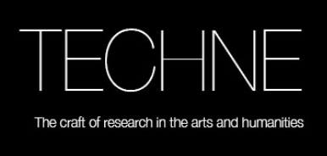
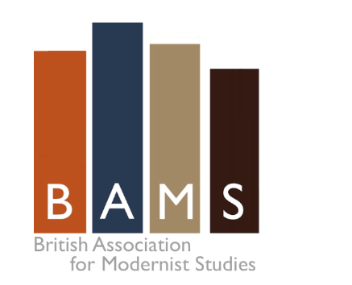

British Association for Modernist Studies

Postgraduate Training Day: Career/Administration

Wed. 28 March 2018

Hosted by the Department of English at Royal Holloway
and the TECHNE consortium

Location: Room 104, Senate House, London WC1 7HU (central London)

The ninth annual BAMS training day this year will focus on career administration and university administration in the early career (especially as it impacts on the expectations of job applicants and ECRs). The focus will be on practical advice, but the day will also allow candidates to focus on the profession as it is currently developing, and to reflect on their own skills, and indeed on how they might be put to use outside academia. While the day is organized by BAMS, its general focus means that students working in other areas should find it equally valuable, students in the TECHNE consortium are especially encouraged to attend.

The training day will be led by members of the BAMS executive Tim Armstrong (Royal Holloway), Alex Goody (Oxford Brooks), Suzanne Hobson (Queen Mary), and Jeff Wallace (Cardiff Met), as well as TECHNE staff.

Programme

10.00-10.30 Coffee and registration

10.30-11.00 Introduction: Trends in UK academia and the Future of English
(Jeff Wallace, Cardiff Met)

An introduction to what is happening in our field at the institutional level and how it might impact on the future of young academics.

11.00-12.30 Session 1: Publishing, collaboration and building a CV (Dr Shelley Trower, Roehampton)

This session will look at career development in general terms: how do you improve your CV, make yourself seem networked and professionally engaged; what are the possibilities for collaboration with others over conferences, publications and grants in the early career. CVs will be workshopped and calls for collaboration put out, so bring yours along!

12.30-1.30 Lunch (Not provided: a list of cafes and sandwich shops will be distributed)

1.30-2.30 Session 2: Applications and interviews (Lise Jaillant, Loughborough;
Tim Armstrong, recent HoD, Royal Holloway)

The focus of this session is to inform you about and discuss interview processes: what the process looks like from the appointment panel’s point of view and what they want (and how they score and rank); what you can do to maximize chances of getting on lists; and how to research departments and do well at interviews.

2.30-3.30 Session 3: Institutional Demands in the Profession: REF, TEF, grant income, student support (Alex Goody, Oxford Brookes; Suzanne Hobson, QM)

Increasingly at interview candidates are expected to know something about the REF, TEF, and to show skills in or knowledge about grant applications, public engagement and Impact. This session offers the chance to hear about and discuss those issues.

3.30-3.50 Coffee

3.50-4.50 Session 4: Marketing your skills and experience: interim support and exit strategies after the PhD (Dr Sophie Oliver, Yale UP; Dr Oli Belas, recently back in academia after 10 years in teaching; Dr Steph Boland, Prospect)

Recent PhDs often face a difficult period of 1-4 years in which they develop careers and CVs, seek book contracts etc, often subsisting on badly-paid PT work. This session will consider how you might survive that period (and indeed non-funded writing-up years), how you might use your skills, and exit strategies at a point where you might want to put your skills to work in other fields.

4.50-5.10 Round Table Q&A

7.30 Dinner (optional)

