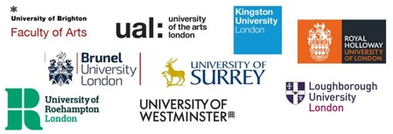

**Techne Post Placement/Training/Undertaking Student Report**

**This form must be completed within 6 weeks of the end of the placement**

**Personal Details**

|  |  |  |  |
| --- | --- | --- | --- |
| Title: | First name: | | Family name: |
| Department: | | Institution: | |
| Email: | | | |

**Project Details**

|  |
| --- |
| Placement Project Title: |
| Placement Partner Organisation: |
| Placement Partner contact (please see additional Partner section below): |
| Your Lead supervisor: |
| Brief outline of the placement? (ca 250 words) |
| How did the Cultural Partner support you during your placement.(ca 250 words) |
| Describe the key deliverables of your placement and impact for you in terms of skills development and career development and the impact for the placement provider. (c. 250 words) |
| Do you have any additional comments you would like to make about your placement? (c.250 words) |
| **To be completed by the Partner Organisation** – please confirm the dates the placement took place  Placement dates:  From …/…/… to …/…/… Number of days per week ……………….. Hours per day: ………………. |
| Please let us know the impact this placement/student has had on your organisation ( not mandatory) |
| Date this section was completed ……………………  Completed by: …………………………………………….. Host Organisation: ……………………………………… |