Pushing the Boundaries

Annual Research Festival
30th June and 1st July 2014
Grand Parade

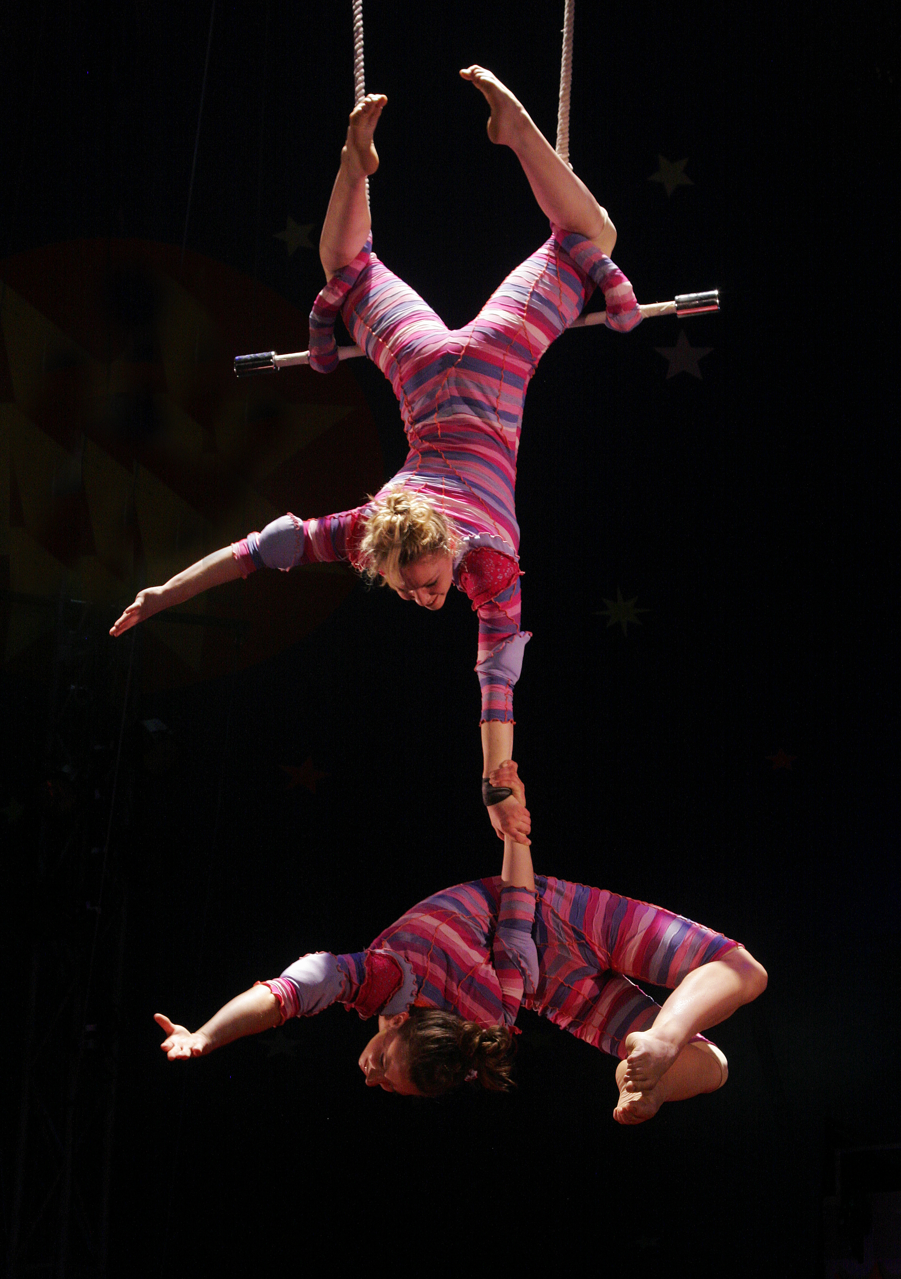

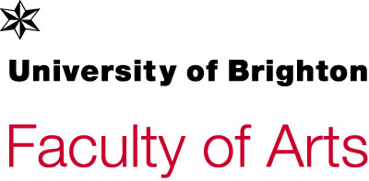

Faculty of Arts’ Annual Research Festival
Pushing the Boundaries
30th June & 1st July 2014

An exploration and celebration of the research taking place within the faculty that pushes and tests the boundaries of research across the faculty. The festival will address the methods by which boundaries are tested and the key issues that are being pushed to the forefront.

Monday 30th June

Abstracts pages 4-7
9:30 | Registration and refreshments | Sallis Benney Theatre
10:00 | Welcome and introduction  Jonathan Woodham
10:10 | Making it Happen  Guest speaker: Tracey Warr
10:40 | ‘New Europeans’ in Contemporary Literature and Culture  Vedrana Velickovic
11:10 | ‘Inherent Vice’: Tracing the Legacies of Atlantic Slavery  Anita Rupprecht
11:40 | Refreshments | Café
12:00 | ‘Too much yellow? Add yellow.’ Photos and narratives: documenting the collaborative process behind the textual-visual research project  Dora Carpenter-Latiri and Simon Sandy | Sallis Benney Theatre
12:30 | Speaking out: Communicative media practices for social change  Julie Doyle
13:00 | The VI-suite: An integrated set of environmental analysis and generative design tools  Ryan Southall
13:30 | Lunch | Café
14:30 | Performance more information to follow  Mikhail Karikis | Sallis Benney Theatre
14:50 | Panel debate: How effective is Performance Art at pushing boundaries?  Alice Fox, Bob Brecher and Mikhail Karikis + tbc Chaired by Alan Boldon
15:10 | Understanding the Characteristics of Design Leaders in Large Fashion Retailers  Karen Miller
15:40 | Design Systemics: Large Technical Systems and Four-Dimensional Objects  Damon Taylor
16:10 | Mapping Social change: Research and Practice  Guy Julier and Jocelyn Bailey
16:40 | Rounding up session-Panel discussion. How can we all continue to push boundaries through our research?  Panel members Peter Lloyd, Cheryl Buckley, Alan Boldon, Katy Shaw. Chaired by Gillian Youngs
17:00 | Drinks  Performances  Faculty of Arts Book Launch- a celebration of recent staff publications. | Café, Quad and Sallis Benney Theatre

Tuesday 1st July
Workshops
Full Content pages
9:00-10:30 | Funding opportunities in the Arts and Humanities  Led by Dr Anne Galliot and Tony Inglis | M2
10:30-11:30 | Staff opportunities for study- MRes and PhD  Led by Professor Darren Newbury and Dr Mary Anne Francis | M57
11:30-13:00 | How to use mentoring in achieving research aims and ambitions  Led by Professor Gillian Youngs | M2
12:00-13:00 | Targeting the right publication  Led by Professor Jeremy Aynsley and Professor Peter Lloyd | M57
13:00-14:00 | Planning your Research  Led by Dr Anne Galliot | M57
14:00-15:00 | Knowing the audience: making an impact in arts and humanities research  Led by Professor Don Macraild, Professor of British and Irish History, University of Ulster | M2
15:00-16:00 | Professors, what do they do?  Led by Professor Cheryl Buckley | M57
15:30-17:00 | Research Student Forum: Work in Progress  Chaired by Professor Alan Tomlinson | M2

Parallel Sessions
Monday 30th June
30th June –  12th July | The Guantanamo Public Memory project exhibition | GP Café
12:00-14:00 | What is the role of art when access to images and information has been denied?  Ethics of Representation students have organised a public/artist engagement project "a conversation" | GP Café
Tuesday 1st July
 | Inclusive Arts Practice student presentations | G4

Faculty of Arts Research Festival
Pushing the Boundaries
30th June 2014
Abstracts

Guest Speaker
Dr Tracey Warr
Making it Happen

Increasing numbers of artists are moving away from individual practice in solitary studios into collaborative practices more akin to group architecture or design studios. Dr Tracey Warr will examine where the boundaries of creativity lay in her own collaborations with artists London Fieldworks and Urbonas Studio. Warr describes herself now as primarily a writer, but her past work also encompassed curating, teaching, researching and collaborations with a range of contemporary artists. Her collaborations with London Fieldworks (Jo Joelson and Bruce Gilchrist based in London and the Scottish Highlands) and Urbonas Studio (Nomeda & Gediminas Urbonas based at MIT in Boston) have been multi-valent and particularly persistent: operating over a few decades. There has been considerable theoretical examination of artists’ ceding aspects of authorship to audiences and participants, but this presentation will focus on artists’ authorship in relation to the other creative practitioners they work with. How does the writer/curator/researcher collaborate with artists? How does that impact on the signature ‘brand’ of artists? Why are many artists’ practicing now in collaborative modes and how does that relate to wider social and economic issues?

Dr Tracey Warr is a writer based in France and Wales. She was formerly Senior Lecturer, Fine Art Theory at Oxford Brookes University and Dartington College of Arts, and Guest Professor at Bauhaus University, Weimar. Her publications include The Artist’s Body (Phaidon, 2000), Marcus Coates (Grizedale, 200?), Setting the Fell on Fire (Editions North, 2010) and essays on contemporary artists published by Merrell, Palgrave, Manchester University Press, Tate and Black Dog. Her current projects are Remote Performances at Outlandia in the Scottish Highlands with London Fieldworks and Resonance Radio and Frontiers in Retreat, art-led research examining fragile ecologies on the edge across Europe, with Urbonas Studio. She is working on a book of her writings on artists entitled Writing in the Vicinity of Art.

Dr Vedrana Velickovic
‘New Europeans’ in Contemporary Literature and Culture
Over the last couple of decades, there has been a steep rise in the number of literary, media and film representations of what is now, for lack of a better term, referred to as the ‘New Europe’: that is, the reconfiguration of Europe after 1989 and following the EU enlargement in 2004 and 2007. In Britain today, together with the rising popularity of UKIP, hardly a week passes without hearing about those very ‘New Europeans’ in the media and the press, or people who are often lumped together under the generalizing and reductive rubric of the 'Eastern European'. This paper examines the re-emergence of this ‘figure’ in a range of contemporary media, film and literary production about and from Eastern Europe. Building on the studies of Balkanism of the late 1990s -- a critical examination of stereotypes and images of Eastern Europe and the Balkans – it will discuss forms of ‘Othering’ that are at work in contemporary representations. The paper will also pose a number of preliminary research questions, such as whether we can trace a similar language previously used with regard to post-1945 black and Asian immigrants, and later to black and Asian British citizens during the 1970s and 1980s in the debates about Eastern European migration, and to what extent postcolonial frameworks are useful for theorizing this recent figuration of an Eastern European ‘white other’.

Dr Anita Rupprecht
‘Inherent Vice’: Tracing the Legacies of Atlantic Slavery

The historical, cultural and political significance of Atlantic slavery in the making of the modern world has long been acknowledged. Questions about how we can further specify the multiple legacies of slaving in the contemporary moment are currently at issue both inside and outside the academy. From the campaign for Reparations to concerns about contemporary human trafficking and from the current emphasis on memorializing Atlantic slavery to an increasingly reactionary set of public discourses about racial justice, questions of how to relate this aspect of an imperial past to the multicultural present are currently the subject of contested public debate.

This paper – part of a larger research project – contributes to the project of tracing slavery’s occluded legacies. To do so, it turns to what might seem like an unpromising archive – that of financial insurance. Thanks to the research of reparations activists, many large multinational corporations have been forced to disclose their early profiteering from the institution. The ways in which the industry, and its legal structures, developed and adapted to the requirements of commodifying life for the purposes of forced migration have been little addressed, however. Moreover, the role of African resistance in disrupting this development has not been an issue to date.
A spectacularly successful slave-ship rebellion that occurred off the coast of Florida in 1841 resulted in an insurance claim on the part of the slave owners. The paper draws on the ensuing legal dispute as a case study to open up further the legacy of the transatlantic slave trade buried within modern speculative finance capitalism: legacy that persists in the everyday availability of life insurance.

Dr Dora Carpenter-Latiri and Simon Sandy
"Too much yellow? Add yellow.” Photos and narratives: documenting the collaborative process behind a textual-visual research project.

This paper will illustrate the collaborative work of Simon Sandy’s (photography) and Dora Carpenter-Latiri’s (humanities) over five portraits of Tunisian women. These women are part of a group of 15 women interviewed and photographed during Dora’s fieldwork for her research project, which won a University sabbatical award for semester 2 of the current academic year. Dora’s project is both textual (interviews + narratives) and visual (photo portraits). The photographic training with Simon was funded by the School of Humanities.

The women interviewed/photographed are women writers or women artists who make books; they all have a close bond with Tunisia, either because they were born there, live there, or their work deals with Tunisia.

All women have been photographed with the same wide-angle 20 mm lens.

The selecting and editing stage was part of Dora’s photographic training; the process was collaborative. When selecting and editing the photos, first of all the photos had to be technically good enough for a colour and a black and white print. Another criterion in selecting the photos was that the final set of photos had to offer a variation in style so that the portraits would reflect the individuality of each woman whilst remaining within the same format. But most importantly the decisive criterion in selecting each photo is how it offers room for a narrative to take shape: the narratives emerge from the verbal material collected in the interviews and from the connections we make with other visual references. It is at this stage that our collaboration is the most creative. Our conversations about the photos are an expression of the interaction between the verbal and the visual medium, they make us question and push the boundaries of each medium. This paper documents an important stage in the research project: although not visible in the final output, this encounter is a vital creative stage, defining the whole project.

Dr Julie Doyle
Speaking out: Communicative media practices for social change

From online news stories to Instagram images, media technologies and practices shape our everyday lives, affecting how and what we communicate, as well as the social values we hold and enact. Media research at Brighton is concerned with examining the complex relationships between communication technologies, economy, culture and society, as a means of enacting social and political change. Central to our research practice is a concern for marginalised groups/identities, for questions of inclusion/exclusion, and for issues of equality, ethics and justice. As such, this presentation will focus upon 3 key areas of media research which attend to these concerns: 1) community media and social engagement; 2) sexualities, youth and social media; 3) climate change communication and action. By highlighting specific research projects and the role of external partnerships, the presentation will illustrate how media research at Brighton pushes both disciplinary and cultural boundaries to help speak out on matters of human and environmental concern in order to effect social change.

Dr Ryan Southall
The VI-Suite. An integrated set of environmental analysis and generative design tools.

The VI-Suite, authored by Dr Ryan Southall of the School of Arts, Design & Media, is a free and open-source integrated set of building environmental analysis tools hosted within the Blender 3D content creation suite. The VI-Suite contains two main components: LiVi - a pre/post-processor for the Radiance lighting simulation suite and EnVi - a pre/post-processor for the EnergyPlus thermal simulation engine. VI-Suite capabilities encompass wind rose and sun path creation and visualisation, shadow study analysis, lighting analysis (basic, compliance testing and Climate Based Daylight Modelling), building thermal analysis, advanced natural ventilation network creation, and Environmental Generative (EnvGen) design. An emphasis is placed within the VI-Suite on geometry manipulation and results visualisation; areas where the VI-Suite has some unique features.
This talk will focus on the choice of Blender as a host application, some of the Vi-Suite's capabilities and a demonstration of its operation

Dr Mikhail Karikis
More information to follow

Dr Karen Miller
Understanding the Characteristics of Design Leaders in Large Fashion Retailers

Recently design leadership has received increased attention, particularly in relation to knowledge intensive organisations such as fashion retailers. However, to date little is known about the nature of individuals in these vital positions. In response, this study aims to identify ‘what’ design leaders ‘do’ (their roles) and ‘what’ they need in order to ‘do’ (their skills). Empirical data was generated during interviews with 26 design leaders in seven UK-based international retailers using a novel method of graphical elicitation. Temporal data on the seven organisations was also mapped through an innovative graphical approach. The results reveal distinct patterns from those previously reported in design leadership and broader leadership literature. Predominantly these relate to designicity, a term that has been introduced to describe how design knowledge is imbued into all aspects of leadership. Additionally this study illustrates that there must be congruence between the skills and knowledge of design leaders and the organisation. Hence, this research contributes to academic knowledge by more clearly defining the need for formal design education and extensive experience in design leadership. By delineating design leaders in this way greater clarity is also provided for education and industry in relation to recruitment and on-going knowledge acquisition.

Dr Damon Taylor
Design Systemics: Large Technical Systems and Four-Dimensional Objects

This research connects the development of material networks or Large Technical Systems, such as the railways and the roads, the national electricity grid and the landline telephone network, the cellphone system and Internet, to the quotidian physicality of the everyday. Through a series of interlinked projects, such as an examination of the forces that allowed the BS1363 electrical plug to become the standard in the UK; the charting of the history of the ‘smart’ home as a technologically regulated and networked interior; and an examination of the way in which data harvesting, ubiquitous computing and augmented reality are impacting more broadly on everyday life, this investigation seeks to ask what it means to live with objects that are implicit in ideologically determined dynamic structures.

Professor Guy Julier and Jocelyn Bailey
Mapping Social Design: Research and Practice

Over the last 9 months we have been commissioned by the AHRC to investigate the field of social design research and practice, in order to advise on their future strategy in this area. In this talk we will present the findings from this mapping project, and our prospective recommendations to AHRC.

Our investigation has a number of 'boundary-breaking' implications. We ask where, in disciplinary terms, social design might most usefully be aligned. Should it more properly be thought of as a branch of social sciences, rather than design? We question who social design research is truly useful for - and whether it is adequately serving its community of practitioners? We look at some staples of social design thinking and practice that perhaps need de-stabilising. And our findings also indicate that social design research itself challenges the structures within which research and action-research is delivered.

Faculty of Arts Research Festival
Pushing the Boundaries
1st July 2014
Workshops

Funding opportunities in the Arts, Humanities and Media
Led by Dr Anne Galliot and Tony Inglis
9:00-10:30 – M2 Grand Parade
How can you fund your research? A workshop run jointly with the Research Office to provide information on funding organisations and the award schemes on offer for research in the arts, humanities and media. This workshop will be of use to researchers at all levels.

Staff opportunities for study- MRes and PhD
Led by Professor Darren Newbury and Dr Mary Anne Francis
10:30-11:30 – M57 Grand Parade
'From 'research' to 'Research': the MRes as academic capital (or capital 'R' research): a guide for staff
This session will introduce the MRes degree as a route into Research understood as 'creative work undertaken on a systematic basis in order to increase the stock of knowledge […]', and as such, something more than research as 'systematic enquiry'. Whether you are interested in undertaking MRes supervision or taking the MRes yourself to develop your Research practice, including creative practice as Research, we aim to show what difference a capital letter might to your work in the Faculty.

And from 'Master' to 'Doctor': Five reasons for doing a PhD: a guide for staff
This session will discuss the opportunities and challenges of doctoral level work for academic staff seeking to develop their research careers, whether from more traditional academic disciplinary backgrounds or from art or design practice. As the PhD has gained currency across a greater range of subjects in higher education in the arts, this session reflects on the PhD as a particular kind of educational experience, the motivations for doing a PhD and its place in research careers.

How to use mentoring in achieving research aims and ambitions
Led by Professor Gillian Youngs
11:30-13:00 – M2 Grand Parade
Success in academic life often depends on different kinds of mentoring and the capacity to know when and who to seek mentoring from as well of course when and how to offer it to a colleague. We can regard understanding of the different roles mentoring can play as part of the academic skill set whether it is connected to developing a personal research identity/strategy/plan or making choices between different opportunities or possibilities opened up or offered at any particular time. Usually academics have a group of mentors who they call on in different ways and for specific purposes at different times so a ‘mentoring relationship’ is created over time in which detailed understanding and trust are developed. Of course there are two aspects to the mentoring picture – being a mentor and a mentee. Long standing mentoring relationships often reflect both dimensions on both sides at different times, others of course feature just one dimension. This workshop will unpack and explore the nature of academic mentoring based on the extensive experience of Prof. Youngs as both a mentee and a mentor.

Targeting the right publication
Led by Professor Jeremy Aynsley and Professor Peter Lloyd
12:00-13:00 – M57 Grand Parade
This workshop will offer an introduction to and guidance on publishing in academic journals. Recent years have seen the proliferation of academic journals. This can present researchers with difficult choices about which journal is best for their work to be published in.

In outlining what is expected of authors who are preparing their work for publication and we will consider questions of what research to publish, choosing where to publish it, deciding when to publish it, and working out how to publish it. We will also map some of the current research themes and emerging trends in leading journals.

The workshop, which requires a small amount of preparatory work, will be of broad interest across the Arts, Architecture, and Design including history, theory and practice.

Planning your Research
Led by Dr Anne Galliot
13:00-14:00 – M57 Grand Parade
The Deputy Director of CRD and the Research Development Adviser will discuss how to plan research as part of your academic career, and demonstrate a planning template that can assist you in doing this. This workshop is suitable for researchers at all levels, and of particular use to early and mid-career researchers.

Knowing the audience: making an impact in arts and humanities research
Led by Professor Don Macraild, Professor of British and Irish History, University of Ulster
14:00-15:00 – M2 Grand Parade
Many humanists think impact is for other subjects: easy in science and engineering, difficult in arts and humanities. This presentation argues that the key to any impact is knowing the audience, understanding who should and can be influenced, and building partnerships and connections that enable this. It will discuss approaches and strategies for getting the best value from your expertise.

Professors, what do they do?
Led by Professor Cheryl Buckley
15:00-16:00 – M57 Grand Parade
To follow

Research Student Forum: Work in Progress
Chaired by Professor Alan Tomlinson
15:30-17:00 – M2 Grand Parade
To follow

Festival Image:
Circus Smirkus Static Trapeze Photo: H. Powers [CC-BY-2.0 (http://creativecommons.org/licenses/by/2.0)], via Wikimedia Commons

