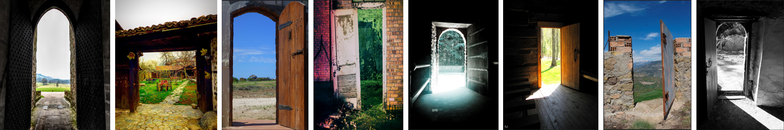

**Negotiating the Threshold: Borders, Boundaries and Doorways in Arts and Humanities Research**

As funding bodies become increasingly focused on the value of research that is collaborative, interdisciplinary and socially relevant, today’s Arts and Humanities researchers face the challenge of actively pursuing projects that take them beyond the confines of their own discipline. In the process of going beyond, we cross thresholds that mark the borders between spaces. This movement beyond may take place on different levels: movement beyond one’s discipline into another; movement beyond academia into community; movement beyond socially accepted norms into new norms; movement beyond personal reflection into action. Movement beyond and into therefore demands that we make sense of what we are doing when we make the move. What precisely are the thresholds that we cross? What is their impact on us and on others before, after and as we move?

The aim of this summer’s TECHNE Congress is to engage with the fundamental challenge of how we, as Arts and Humanities researchers, make sense of the movement beyond – how we negotiate the threshold between spaces. The Congress will provide various spaces for conversations around the themes of borders, boundaries and doorways to encourage creative reflection on how we negotiate these thresholds. We will explore these themes from perspectives including the role of Arts and Humanities in today’s world; strategies for crossing borders and boundaries in the real world and in academia; the impact on identity when negotiating thresholds and when making the return; the breaking down of borders between human and non-human health; and the relationship between physical space and social interaction.

An important element of the Congress will be the programme structure over the two days, in which delegates will move from spaces for large, interactive group sessions to spaces for personal reflection and small group conversations. We hope this flow from one space to another will stimulate creative engagement around the themes that will help us all to make better sense of the thresholds we cross in our research.



Copyright of image from left to right:

Dave McGlinchey; Nyssa Mirza; Desert Wave; Just Add Light; Jules Peeters; Chuck; Saleh Young; Anthony Rowe LRPS

**DAY 1 – Tuesday 4th July**

|  |  |  |  |
| --- | --- | --- | --- |
| **Times** | **Sessions** | **Room** | **Speakers** |
| 10.00 to 11.00 | Registration Tea/Coffee | Vet School Atrium |  |
| 11:00 to 11:15 | Welcome and Introduction | Vet School Atrium | Katie Normington, TECHNE Director and Professor Chris France, Director of Doctoral College, Surrey |
| 11:15 to 12:45 | Keynote Lecture | Lecture Theatre 1 | Kim Knott |
| 12:45 to 14:00 | Lunch and Networking | Vet School Atrium |  |
| **Session 1** 14:00 to 15:15 | Disciplinary Borders Talk | Lecture Theatre 2 | Nina Power |
| Doors Presentations | Seminar Room | Matthew Wagner and Stuart Andrews |
| Translation Talk | Seminar Room | Sara Dicerto |
| Private and Public Talk | Seminar Room | Bran Nicol |
| Topography of the Threshold 1 | Seminar Room | Chair: Fearghus Roulston, Speakers: Kevin Biderman, Laura Oldfield Ford and James O’Leary |
| GeoHumanities Panel | Seminar Room | Chair: Phil Crang, Speakers: Sasha Engelmann, Jonathan Moses, Sofie Narbed and Cecilie Sachs Olsen |
| Calming Companion Robotics Workshop | Atrium & Seminar Room | Amie Rai |
| 15:15 to 15:35 | Break for Tea/Coffee | Vet School Atrium |  |
| **Session 2** 15:35 to 16:50 | Disciplinary Borders Q&A | Lecture Theatre 2 | Nina Power |
| Doors Presentations | Seminar Room | Matthew Wagner and Stuart Andrews |
| Translation Talk | Seminar Room | Sara Dicerto |
| Private and Public Talk | Seminar Room | Bran Nicol |
| Topography of the Threshold 2 | Seminar Room | Chair: James O’Leary, Speakers: Konstantinos Gousis, Flora Parrott and Nick Mayhew-Smith |
| GeoHumanities Panel | Seminar Room | Chair: Phil Crang, Speakers: Sasha Engelmann, Jonathan Moses, Sofie Narbed and Cecilie Sachs Olsen |
| Calming Companion Robotics Workshop | Atrium & Seminar Room | Amie Rai |
| 17:30 | Transport to Travelodge | Vet School to Travelodge | |
| 18:45 & 22:00 | Evening Meal Transport | Travelodge to the Refectory and return | |
| 19:15 to 22:00 | Evening Meal and presentation at Guildford Cathedral Refectory | | |

**DAY 2 – Wednesday 5th July**

|  |  |  |  |  |
| --- | --- | --- | --- | --- |
| **Times** | **Sessions** | | **Room** | **Speakers** |
| 9.30 to 10.00 | Registration Tea/Coffee | | Vet School Atrium |  |
| 10:00 to 11:00 | Keynote Lecture 2 | | Lecture Theatre 1 | Jackie Malton and Deborah Jermyn |
| **Session 3** 11:00 to 12:30 | Student-Led Conference Meeting | | Lecture Theatre 1 | Solene Heinzl and Gillian McIver |
| “How do you get the job you want?” | | Lecture Theatre 2 | Hayley Cordingley |
| Student Online Journal Meeting | | Seminar Room | Rachel Lee Marsh |
| Partner 1:1 The Culture Capital Exchange | | Seminar Room | Enrico Bertelli (TCCE) |
| Open Access, Open Research, Open Society | | Seminar Room | Christian Gilliam |
| Angel Productions Film – what to do after PhD | | Seminar Room |  |
| Mindfulness | | Seminar Room | Heather Nunn |
| Calming Companion Robotics Workshop | | Atrium, Seminar | Amie Rai |
| 12:30 to 13:30 | Lunch and CV 1:1 Consultations | | Vet School Atrium | Hayley Cordingley, Ruth Livesey and Helen Minors |
| **Session 4** 13:30 to 14:45 | The Craft of Writing Fiction Talk | | Lecture Theatre 2 | Monica Ali (Facilitated by Bran Nicol |
| Medical Humanities Panel | | Seminar Room | Chair: Michael Brown, Speakers: Ali Mobasheri, Simon Bettles and Andrew Bevan |
| Boundaries encountered in Academia | | Seminar Room | Allan Johnson |
| Interwoven Thresholds | | Seminar Room | Miguel Á. Bernal Merino |
| Writing a 4* Journal Paper | | Seminar Room | Phil Powrie |
| Calming Companion Robotics Workshop | | Atrium & Seminar | Amie Rai |
| 14:45 to 15:05 | Break | **Walking Tour departs** | Atrium | Neal Cahoon and Nick Mayhew-Smith |
| **Session 5** 15:05 to 16:20 | The Craft of Writing Fiction (Group session) | | Seminar Room | Monica Ali (Facilitated by Bran Nicol) |
| Medical Humanities Panel | | Seminar Room | Chair: Michael Brown, Speakers: Ali Mobasheri, Simon Bettles and Andrew Bevan |
| Boundaries encountered in Academia | | Seminar Room | Allan Johnson |
| Interwoven Thresholds | | Seminar Room | Miguel Á. Bernal Merino |
| Writing a 4* Journal Paper | | Seminar Room | Phil Powrie |
| 16:20 | Closing Reception with presentation of creativity activity + Feedback forms | | | |

**Administration**

**Luggage**

We have a bag store at the Vet School though we recommend that you keep any valuables with you.

**For those participating in the Walking Workshop:** Nick Mayhew-Smith will transport baggage to Shere in the morning so that participants do not have to return to Surrey university. Please leave your bags at the registration desks tagged for the Walk before 11am. Bags will be left in Nick’s car at the owner’s risk.

**Dietary and access requirements**

We have used the information you have provided us at either the Welcome Event or more recently the Congresses. Please let us know if anything has changed.

**Accommodation**

Overnight accommodation and breakfast for those that have booked overnight accommodation, is at the Travelodge, Guildford GU1 1BD.  Coaches have been booked for transfers between the Vet School, the Travelodge and the Cathedral (please see the timetable below).

**Parallel sessions and Repeating sessions**

Please book your parallel sessions through Eventbrite by the 23rd June and note that there is limited space on some of them. Some of the sessions will be run twice on the same afternoon and are not a continuation of the previous one unless indicated otherwise.

There will be sign-up sheets at registration for the Partner 1:1 with Enrico Bertelli of The Culture Capital Exchange (TCCE) and the CV 1:1 consultations. If you would like to have a CV 1:1 consultation, please bring a copy of your CV.

**Parking**

Please book your parking space through Eventbrite and we will send you parking instructions closer to the date. Parking near the Vet School is limited and we cannot guarantee availability. Parking at the Travelodge is also limited and it is not possible to book spaces.

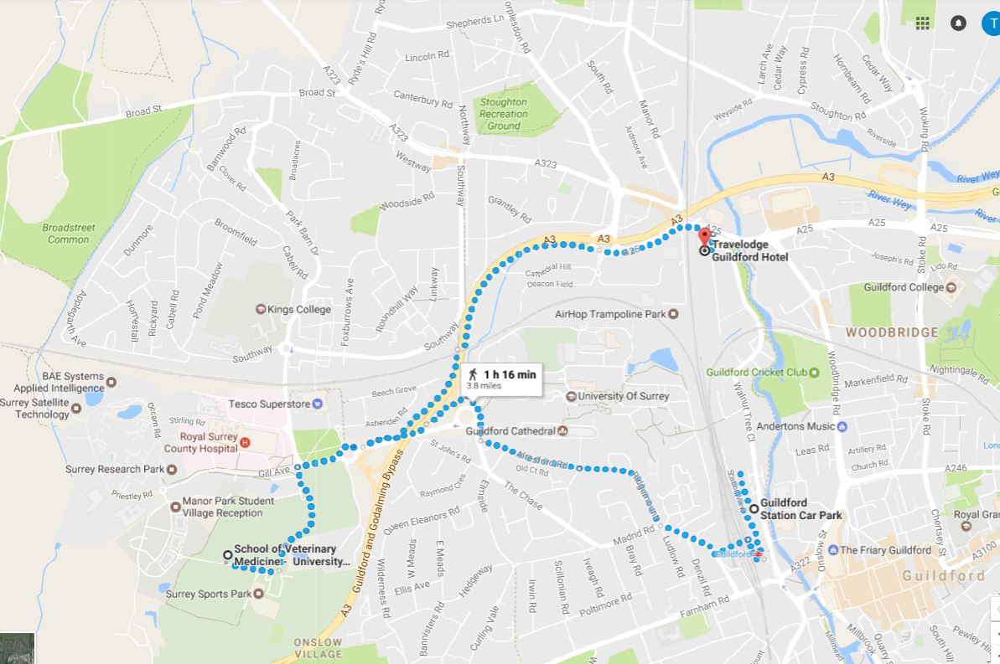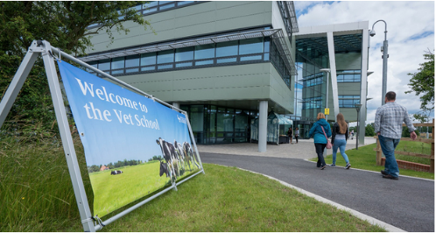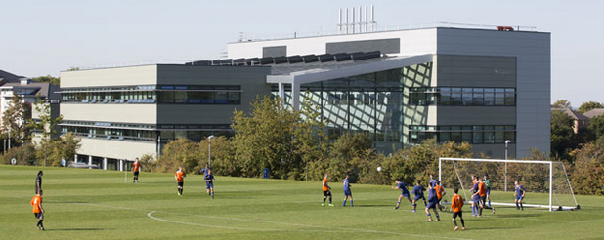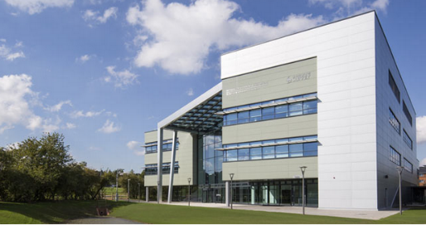

**How to find the Vet School**

**Address:** Vet School Main Building (VSM), Daphne Jackson Road, Guildford, Surrey GU2 7AL

**The Vet School is not on the main campus of Surrey University but on the Manor Park campus close to the Surrey Sports Park. For directions to Surrey Sports Park, please follow this link:** <http://www.surreysportspark.co.uk/guestinformation/howtofindus/>

**University of Surrey Campus map:** <https://www.surrey.ac.uk/files/pdf/campusmap.pdf>

**By Train:**

Guildford is on the main line between London Waterloo and Portsmouth. Half-hourly train services run from Guildford to Waterloo, with journey times of 40 minutes. Please see the timetable below for the coach times we have booked.

Walking from the train station: Leave the station by the footbridge and rear exit. Turn right from the station along Guildford Park Road and continue along Madrid Road and The Chase for a mile. Follow the path past Guildford Cathedral to the main University of Surrey campus entrance. At the entrance turn left through the woodland area and follow the path through two underpasses until you reach Tesco. Follow the main road (Egerton Road) until you reach the traffic lights, where you will want to turn left and cross Egerton Road, in the direction of the rugby pitches visible from the road. The entrance to Surrey Sports Park is accessible via Richard Meyjes Road. (20-25 mins) (please see the walking map attached to the email)

By Bus**:** ARRIVA buses (leave station by footbridge and rear exit, cross main road to bus stop) operates a regular service to Surrey Sports Park via its 27 and 26 bus services, which currently provide a 20 minute frequent link during the main part of the day on Mondays to Saturdays, and every half-hour during the evenings and Sundays. Egerton Road (Tesco) and the Royal Surrey County Hospital are both a short walk from the Vet School and the 3, 4, 5, **26, 27**, 36 and 37 busses run approximately every ten minutes during the day.

**Bus Timetable:** <http://www.surrey.ac.uk/currentstudents/campus/transport/bus/guildfordlocalbusservices.pdf>

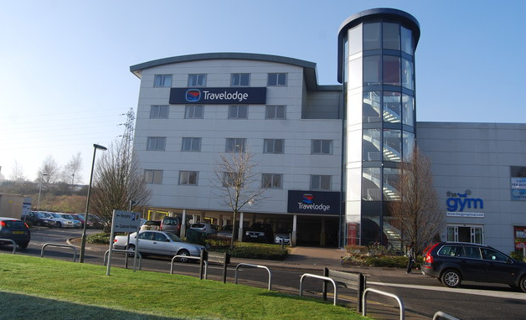**How to find the Travelodge**

[**Address**](https://www.google.co.uk/search?biw=1347&bih=965&q=travelodge+guildford+address&stick=H4sIAAAAAAAAAOPgE-LWT9c3LDfIMs6LN9WSzU620s_JT04syczPgzOsElNSilKLiwEavPqvLgAAAA&sa=X&sqi=2&ved=0ahUKEwjdt8qtlJ_UAhWPZ1AKHTQtBIAQ6BMIvAEwDw)**:** Travelodge, Woodbridge Meadows, Guildford, GU1 1BD

**Directions by Car:** Leave the M25 at junction 10 (signposted London, Guildford, Kingston) Take Portsmouth Road A3 (signposted Guildford). Continue along the A3 for 7.5 miles. Leave the A3 at the junction for Guildford (A320) Branch left, then at traffic signals turn left onto Woking Road A320 (signposted Guildford), entering Guildford. At Stoke Crossroads turn right onto Ladymead A25 (signposted Guildford). At traffic signals continue forward (signposted Bagshot) Turn left 100 yards onto Woodbridge Meadows and then turn right to arrive at Guildford Travelodge.

**By Bus:** Bus service 27 from Egerton Road (Near Vet School) goes to Woodbridge Meadows (Travelodge). Bus Service 26 and 4A from Woodbridge Meadows goes to Royal Surrey Hospital stop, which is a short walk from the Vet School.

**Coach Transfers from Train Station, Vet School, Travelodge and Cathedral (Newtons)**

**Day 1: Tuesday 4th July 2017**

|  |  |  |
| --- | --- | --- |
| Guildford Train Station | Surrey Vet School | 10:00, 10:15 |
| Surrey Vet School | Travelodge | 17:15, 17:30 |
| Travelodge | Guildford Cathedral Refectory | 18:45, 19:00 |
| Guildford Cathedral Refectory | Travelodge | 22:00 |

**Day 2: Wednesday 5th July 2017**

|  |  |  |
| --- | --- | --- |
| Travelodge | Surrey Vet School | 09:15, 09:30 |
| Surrey Vet School | St Catherine’s Chapel | 14:45 |
| Surrey Vet School | Guildford Train Station | 16:30 |

**DAY 1 – Tuesday 4th July Session Information**

11:15am to 12:45pm

**The Metaphorical Thresholds we Live by, their Affordances and Constraints – Keynote Lecture by Kim Knott**

Drawing on research on spatial theory and method, and my career as a scholar of religions, I will explore the Congress metaphors and reflect on what they limit, forget and allow. Walls and doors are everywhere, but the ones on which I’ll focus juxtapose the academy and beyond (communities and stakeholders), research and teaching, different disciplines, life stages and hidden obstacles.

14:00 – 15:15pm, Sessions Repeating at 15:35 – 16:50pm

**Disciplinary Borders Lecture by Nina Power**

‘Disciplinary Borders. This lecture will describe and discuss the positive and negative dimensions of interdisciplinarity and transdiciplinarity, noting where there are important differences between the two approaches, and how different methodological approaches in the Arts and Humanities serve different functions. The lecture will also address academia’s ‘borders’ with the world outside, where these borders are assumed and where these might actually reside. It will attempt to think about the way in which disciplinary borders both inhibit and enable academic work, and how this relates to our understanding of larger borders in the world – geographical, linguistic, political.’

**Conversations on the Door: Investigating the door as site, object and threshold in theatre and performance (Speakers: Stuart Andrews and Matt Wagner)**

In this session, we will reflect on our ongoing research into the door in theatre and performance, raise issues from our current and recent investigations and begin to mark out the significance of the door as a threshold. To situate this work, we will discuss our joint research project, ‘The Door: A Practical Study of Site, Object, and Threshold in Theatre and Performance’, funded by the British Academy and Leverhulme Trust (2014-2015), and the forthcoming monograph that has grown out of that project. The session will comprise presentation and discussion.

**Translation (Speaker: Sara Dicerto)**

Multimodal texts present an extra challenge for translators, as they do not contain 'just' words. The meaning of images and sounds also needs to be accounted for in the translation process - but how exactly do we understand multimodal texts? This talk will explore the way such texts are organised and investigate strategies for their translation.

**‘In the Private Eye’: Public and Private Spaces in Noir Talk (Speaker: Bran Nicol)**

This talk examines the interplay – or boundary – between public and private spaces as represented in examples of classic film noir. What does it mean to appear ‘in the private eye’, and how is this different from being in the *public* eye? I explore these questions in relation to a range of films, and the practices of those shadowy private eyes employed by news organisations who not long ago entered the public eye themselves, as well as in the context of writing my book *The Private Eye* (2013), in which I develop these arguments.

**Topography of the Threshold Panel 1 & 2 (Chair: Fearghus Roulston and James O’ Leary)**

The threshold is a primary architectural construct, defining spatial distinctions and demarcating territories, zones and jurisdictions. Thresholds operate in the realms of the material, the virtual, the psychological and the temporal. This afternoon of paired events sees a panel of selected architects, artists and researchers examine the topography of the threshold across a range of differing perspectives, exploring ideas of surveillance, cartography, psychogeography, interface, border, underground and ritual.

**14.00pm to 15:15pm - TOPOGRAPHY OF THE THRESHOLD 1**

Discussion - Chaired by Fearghus Roulston

Presenters:

Kevin Biderman - Surveillance in the City of London

Laura Oldfield Ford - Threshold Cartographies: the Poetics of Contested Space

James O’Leary - The Origin of the Peacewalls in Belfast

**15.35pm to 16:50pm - TOPOGRAPHY OF THE THRESHOLD 2**

Discussion - Chaired by James O’Leary

Presenters:

Konstantinos Gousis - Borderlines & Activism during the Greek Crisis

Flora Parrott - Knowing the Underground: Embodied Engagements with Subterranean Spaces.

Nick Mayhew-Smith - Rituals on the edge of Heaven and Earth

**Calming Companion Robotics Workshop led by Amie Rai**

Over two-days, we will work together to create a research companion that can sooth us through the research journey. We will develop a robotic animal that can respond to a researcher’s mood by monitoring their heart rate and temperature. If our companion detects an anxious researcher, it will give off relaxing scents, calming sounds and ambient lighting to create a more productive environment.

In the workshop, you will work in groups to:

* Consider sounds and smells that affect your productivity and resting modes
* Use practical skills in basic robotics to operate your calming companion
* Help design and create an animal companion using natural and recycled materials
* Our Calming Companion will come to life with the collective efforts of several groups over the two days.

**GeoHumanities: crossing disciplines in search of atmospheres, places, performances Panel (Chair: Phil Crang)**

In Ancient Greek, ‘Geo-‘ designates both the planet ‘Earth’ – its land, sea, air -- and its ‘Worlds’ -- the spaces and places that we humans inhabit and shape. The GeoHumanities is an emergent interdisciplinary field that advocates the crucial contribution of arts and humanities sensibilities to our engagements with the ‘Geo’. Prompted by reflections from arts and humanities researchers with a disciplinary home in Geography, this session will focus on cross-disciplinary ‘doorways’ for engaging Earth and Worlds, with a specific focus on questions of atmospheres, places and performances. The panellists are: Philip Crang (Professor of Cultural Geography and Co-Director of the Royal Holloway Centre for the GeoHumanities), Sasha Engelmann (Lecturer in GeoHumanities, Royal Holloway), Jonathan Moses (TECHNE PhD Student in Historical Geography, Royal Holloway), Sofie Narbed (Teaching Fellow in Cultural Geography, Royal Holloway) and Cecilie Sachs Olsen (Lecturer in Social and Cultural Geography, Royal Holloway).

**Speakers:** Sasha Engelmann, Jonathan Moses, Sofie Narbed, Cecilie Sachs Olsen

**DAY 2 – Wednesday 5th July**

10:00 to 11:00am Keynote Lecture by Jackie Maldon and Deborah Jermyn

**Freedom from the bondage of self: the transformative power of crossing thresholds**

Jackie Malton, best known as the inspiration for the character of DCI Jane Tennison in the *Prime Suspect* drama written by Linda La Plante, has encountered boundaries and thresholds of various types in both her career and her personal life. In conversation with Deborah Jermyn, author of the first critical study of the Prime Suspect drama series, Jackie reflects on how the series helped her to cross the threshold between policing and filming. She speaks about how, in that very process of crossing this professional threshold, she undertook a profoundly transformative inner journey to find her authentic self.

11:00am to 12:30pm Workshops

**Student Led Conference meeting by Solene Heinzl and Gillian McIver**

The session will introduce the planning for the 2017 Conference, and invite students’ ideas and feedback. It will invite you to consider being involved in the conference delivery, and will explain the different roles and opportunities. It will also encourage you to consider proposing papers, practice-led presentations and performances for the event.

This year’s event will have a strand for the “Audio-Visual Essay” and we encourage researchers *in all disciplines* to consider submitting an AV Essay. Gillian will hold a mini-workshop on AV Essay-making, with practical tips and examples, so that you can think about making and submitting AV Essays to the conference.

**“How do you get the job you want?” led by Hayley Cordingley**

It sounds like a simple question, but getting the job you want is a multi-layered project that takes time and energy:

* At the top level, there is work to be done around investigating and deciding the career path(s) you want to pursue.
* At the next level there is finding the opportunity – Does a vacancy exist? How do I find it?  Can I get it created for me? Is there funding available for my initiative?
* At the next level there is understanding what the employer/funder is looking for and marketing yourself effectively to get invited in.
* At the final level there is performing well when being interviewed, and transitioning well to the new situation.

This interactive workshop is designed to give a whistlestop tour of some of the frameworks and resources available to help you with your career decisions, and through a variety of group activities, to share your experiences, learn from each other and plan your next steps.

**Calming Companion Robotics Workshop led by Amie Rai** (as before)

**Student Online Journal Meeting led by Rachel Lee Marsh**

This is an opportunity to find out more about the TECHNE Online Student Journal ‘Logios’ and how you might get involved in editing and supporting production.

**Partner 1:1 with Enrico Bertelli The Culture Capital Exchange (TCCE)**

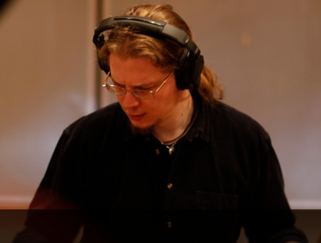An opportunity to have a 15 minute 1:1 Dr Enrico Bertelli (please sign up at the registration desk).

Dr Enrico Bertelli is the Business Development Manager at TCCE and Founder Director of Conductive Music CIC. Enrico is a social entrepreneur, a performance-led researcher, and an internationally renowned performer, specialising in contemporary music and cross-media, technology-mediated performance. Founder of Conductive Music CIC, he specialises in contemporary music and in integrating cutting edge technology to boost public outreach and deliver employability skills to students from challenging backgrounds.

**Open Access, Open Research, Open Society led by Christian Gilliam**

It is increasingly the case that open access to research outputs includes open access to electronic theses. A large number of UK, US and European universities now require PhD students to submit an electronic copy of their thesis and to grant open access rights. A number of concerns have since arisen, concerning the effect open access e-theses (OAETs) have on plagiarism, research integrity and future publishing opportunities. This sessions looks into the all three areas of concern, with the aim of equipping participants with a nuanced understanding of the Open Research movement and how to best use the personal, economic and social opportunities therein.

**Angel Productions Film – what to do after PhD**

**A PhD by itself is rarely enough to launch a career these days, whether in academia or anywhere else.  So what else should PhD students do, apart from working on their thesis, to become employable?**

Through drama scenes, expert interviews and documentary case studies of recent PhD graduates, including a young academic, someone employed outside academia, and someone who has started his own business, The 'What Next?' Video offers practical advice for becoming employable on completion.  Topics include:

* expanding your skill set and developing your CV
* identifying your transferable skills
* thinking outside the academic box
* finding good careers advice

The 'What Next?' Video was produced in partnership with Royal Holloway, University of London, and with advice from Professor John Wakeford, Director of the Missenden Centre for the Development of Higher Education, as part of our [**series for doctoral students**](http://www.angelproductions.co.uk/universities.htm).

**Mindfulness led by Heather Nunn**

Academic life is very much about constantly ‘doing’: critically thinking, building research profiles, producing new research, presenting findings, passing upgrades, networking, teaching and so on. It is rewarding and challenging but it can also be tiring, frustrating and stressful. How often do you get the chance to stop? To step out of the pressures and deadlines and goals of academic life? Mindfulness is a simple, active way of stopping and being present with yourself in the moment in a non-judgmental way. In this session, I will briefly talk about my own experience of arriving at Mindfulness and invite you to try out some simple Mindfulness exercises I have practiced in workshops. Just come with curiosity and you can try to check in with yourself and shift into the ‘being mode’, for a moment. As Jon Kabat-Zinn, founder of contemporary Mindfulness-based stress reduction comments, ‘Mindfulness provides a simple but powerful route for getting ourselves unstuck, back into touch with our own wisdom and vitality’.

12:30 to 13:30 Lunch and 1:1 CV Consultations

**1:1 CV Consultations with Hayley Cordingley, Ruth Livesey and Helen Minors**

How to develop a strong CV for academic job applications and get shortlisted. How to present your research, teaching and other activities in a way that counts with selection panels. Strategies to develop employability. Please bring your CV along for guidance from Hayley, Ruth and Helen. Please see biographies at the end of the document and sign up at the registration desk.

13:30 to 14:45pm, 15:05 to 16:20 Sessions

**The Craft of Writing Fiction by Monica Ali (Facilitated by Bran Nicol)**

In this plenary session, Monica Ali, the Distinguished Writer in Residence at the University of Surrey, will be in discussion with Prof Bran Nicol covering issues of interest to PGRs surrounding the 'craft' of writing, the realities of completing long projects, and overcoming boundaries in academia and beyond, as well as exploring broader questions about writing fiction and its relationship to 'the real world'. After the session she will give a Q&A sessions explicitly for those students working on practitioner doctorates.

**Medical Humanities Panel (Chair: Michael Brown)**

Medical Humanities is a relatively younginterdisciplinary area that explores the social, historical and cultural dimensions of medicine. One of the aims of the discipline is to promote critical dialogue between academics in humanities disciplines and healthcare experts. In this panel discussion, specialists in the fields of Medical Humanities, Veterinary Science, Health Science and Philosophy, will draw on their respective areas of expertise to reflect on the role of emotions in the operating theatre. They will consider the relationship between surgeon, nurse and patient (both human and animal) from historical, philosophical and medical scientific perspectives.

Speakers: Ali Mobasheri, Simon Bettles, Andrew Bevan

**Boundaries encountered in Academia (Speakers: Allan Johnson and Charlotte Mathieson)**

**Charlotte Mathieson**

‘Balancing teaching and research: priorities, challenges, strategies’

Creating a rounded profile of teaching, research, and other activities is essential to being employable post-PhD, but it can be challenging to balance these competing demands and know where to draw the lines. In this session I’ll consider how to best prioritise and strategise in order to use your time most effectively, and look at how you can work across the boundaries of different activities in stimulating and productive ways.

**Allan Johnson**

‘Identity Management for the Contemporary Academic: Social Media, Public Engagement, and Stepping out of the Ivory Tower’

The pressures on academics to engage in meaningful ways with audiences outside of academia is growing, creating new challenges for how we create and understand our public identity.  This session will look at a number of aspects of identity management for the contemporary academic, including social media, public engagement, and working with print and broadcast media.  Drawing upon relevant principles of public relations, we will work toward a clearer understanding of how we as academics can best represent ourselves both within and beyond the boundaries of academia.

**“Interwoven Thresholds: the benefits of interdisciplinary arts and humanities research” Talk (Speaker: Miguel Á. Bernal Merino)**

Bringing together the leading international research on localisation in television, cinema, music and video games, this session looks into the myriad ways in which entertainment products content are adapted for different markets across linguistic, cultural and political borders. We will examine the most significant localisation trends and practices integrating practices and theories from audiovisual translation studies, TV franchising, cinema remakes, music reversioning and video game glocalisation. Drawing together insights from across the wider entertainment industries and the various theoretical frameworks utilised to analyse the adaptation of their products, this session provides interdisciplinary tools for studying culture in our new hyperconnected world, and highlights the benefits of this approach in arts and humanities research.

**Writing a 4* Journal Paper Workshop by Phil Powrie**

The term ‘paradigm-shifting’ has sometimes been used to describe a 4*-star research output. It is the top grade in the Research Excellence Framework; it is what will earn you the respect of your peers; it is what will get you a job more quickly. As a PhD candidate, you should be doing something ‘original’. How do you go from the ordinarily ‘original’ (different from everyone else, which is what all PhD candidates have to do) to the exceptionally original (‘paradigm-shifting’)? The workshop is in three parts:

1. I will explain how the 4* category has evolved, and give you the benefit of my experience as a journal editor and reviewer of many articles and books for a variety of publishers: the importance of abstracts, of references, of presentation, and above all how you frame your research. This is not a presentation, but an interactive session where I will be asking you questions.
2. You will identify how you think your research might be ‘paradigm-shifting’, in pairs and then to the group.
3. We will establish commonalities, but also differences across the various disciplines represented.

**Calming Companion Robotics Workshop led by Amie Rai (as before)**

14:45 to 16:20pm Walking Workshop

**Walking Workshop: Landscapes, Soundscapes, Churches & The Hunt for the Whitzibu - From St Catherine’s to The Silent Pool (Walking Expedition - approx. 3-4 hrs) - Neal Cahoon & Nick Mayhew-Smith.**

This workshop involves a 10km walking tour along the North Downs Way. During the walk we will visit several sites of the Guildford countryside, including: St Martha’s church, Newlands Corner, and The Silent Pool. Neal will introduce his text and sound installation, made in collaboration with Surrey Hills Arts through TECHNE’s engagement opportunity scheme. Nick will speak about the way religion has worked and reworked this ancient landscape as we walk along a section of The Pilgrim's Way. The walk will conclude with gin tasting at The Silent Pool Distillery & optional dinner in the medieval village of Shere (Max. 15 people. Return transport and baggage storage will be provided. There will be an option of eating at Shere at the end of the walk.

A coach will leave the Congress venue at 14:45pm to take participants to the start of the walk at St Catherine’s Chapel. Appropriate clothing and footwear for a 10km hike is essential and you should ensure that you carry enough water – at least one litre is recommended. Bring sunscreen and medication if necessary. Please take extra care when crossing roads in the area and beware of cyclists travelling at speed on both roads and by-ways. Participants will need to find their own way back from Shere to Guildford via public bus which takes about 40 minutes (see <https://bustimes.org.uk/localities/E0051769> or <https://www.surreycc.gov.uk/roads-and-transport/buses-and-trains/bus-timetables/guildford-godalming-and-haslemere-bus-timetables> ) or taxi.

**Speaker Biographies**

|  |
| --- |
| Miguel Ángel Bernal-Merino**Dr Miguel Á. Bernal Merino** researches in the localisation of entertainment media. His research favours a multidisciplinary approach, integrating translation, media, music and film studies. He is a respected member of the Higher Education Academy and the research councils, and helps universities across Europe as an external examiner and an international research excellence assessor. He created the main fora for the discussion of professional video game localisation at the core of the game development industry (GDC) and the software localisation sector (GLRT). His publications have had a very positive impact on professional practice and he is regularly called upon as a private consultant and keynote speaker by companies across Europe. He also champions language learning through enriched media, and he collaborates with Routes into Languages across the UK, visiting schools to inspire teachers and children alike about independent and embedded learning. |
| http://www.surrey.ac.uk/englishandlanguages/images/Staff%20Profile%20Images/monica_ali.jpeg**Monica Ali** is the University of Surrey’s Distinguished Writer in Residence and an award-winning writer, whose novels include Brick Lane (which was short-listed for the Man Booker Prize), In the Kitchen and Untold Story. Her work has been translated into 26 languages.  She has been a visiting Professor on the MFA course at Columbia University, New York, and has tutored on the novel writing MA at City University, London. She has also tutored for the Arvon Foundation. She has been a guest editor of BBC Radio 4’s Today programme, has been a contributor to many other media outlets, and is an occasional literary reviewer for the New York Times. Monica has been a judge for, amongst others, the BBC Short Story Award, and the Royal Society Winton Prize for science books.  She is a Patron of the SI Leeds Prize for unpublished fiction by Black and Asian women. She is also a member of the Independent Monitoring Board for HMP Brixton, and a trustee of the St. Giles Trust, a charity that helps ex-offenders to turn their lives around. |
| **<http://www.surrey.ac.uk/GSA/People/staffprofile_images/stuartandrews.jpg>**  **Dr Stuart Andrews** Senior Lecturer in Theatre and Performance at University of Surrey. Stuart researches installations and performances that engage with place. He has published in *Contemporary Theatre Review* and, with Jocelyn Spence and David Frohlich, in the *Journal of Media Practice* and *Digital Creativity*. He is currently developing two monographs, one on performing home and one, with Matthew Wagner, on the door. |
| https://www.surrey.ac.uk/healthsciences/people/Images/simon_bettles.htm**Simon Bettles** is Teaching Fellow and Lead for Simulation Education in the School of Health Science at the University of Surrey. His main areas of research interest are in education and acute care, specifically theatre processes, simulation, anaesthetics, emergency and trauma care, and patient safety. Simon has extensive practical experience of the NHS, having been responsible for a Day Surgery Unit, maternity provisions for the anaesthetic department and the manager for a busy Post Anaesthetic Care Unit. |
| **Andrew Bevan**  **Andrew Bevan** is a 2nd year TECHNE Researcher at Kingston University exploring the concept of affect in philosophy and neuroscience and its identity or difference from related concepts like emotion, passion and sensation. His thesis is that affect conceptualises reconfigurations in the dynamics of materialization which requires rethinking the problem of affect and time to permit interventions in the wider socio-cultural context. |
| Kevin Biderman **Kevin Biderman** is a lecturer, filmmaker and researcher based in London. He is currently in his 2nd year undertaking a TECHNE funded PhD at the Royal College of Art examining Visual Surveillance in the City of London – from the Ring of Steel to the present day. |
| Michael Brown**Michael Brown** is Reader in the Department of Humanities at the University of Roehampton. His main research interest is in the social and cultural history of medicine and surgery in late eighteenth- and nineteenth-century Britain. He is particularly interested in the cultures, ideologies and politics of the British medical profession. He is currently working on a Welcome Trust funded project entitled 'A Theatre of Emotions: The Affective Landscape of Nineteenth-Century British Surgery'. This four-year project, which started September 2016, explores the place of emotion within the practice, politics and representation of nineteenth-century surgery. |
| http://blogs.surrey.ac.uk/careers/wp-content/uploads/sites/63/2017/03/h.cordingley.jpg**Dr Hayley Cordingley** has worked as a Careers Adviser supporting PGR Students and Early Career Researchers at the University of Surrey since January 2017. She started her career as a PhD researcher, worked in large Pharma R&D in various roles for 10 years, returned to academia in 2007 working as a project manager and researcher on various projects including a technology spin–out opportunity, before transitioning to a researcher developer role in 2012. As her career has included working in, and at the interface of, international corporates, academia, and SMEs, she naturally moved into role in Employability and Careers, where she is passionate about helping researchers navigate their careers – realise and articulate their values and skills, be aware of the range of opportunities available to them, and nail the job application process. |
| Philip Crang**Professor Phillip Crang** is Professor of Cultural Geography and Co-Director of the Royal Holloway Centre for the GeoHumanities. His research interests centre on the feel of particular places and the movements of things, people and ideas that help to give them those distinctive textures. |
| Sara Dicerto**Sara Dicerto** is a Research Associate at King's College London and a Modern Foreign Language teacher at Ark Globe Academy. Her research interests focus on translation of multimodality, translation and Pragmatics, translator training and interpreter training. |
| [Image result for sasha engelmann](https://www.researchgate.net/profile/Sasha_Engelmann)**Sasha Engelmann** is Lecturer in GeoHumanities at Royal Holloway University of London. Her research focuses on atmosphere, sensing practices and dispositions to the environment. In her doctoral research she collaborated with Studio Tomás Saraceno, including on the Aerocene project; her next work is focused on radio amateurs and their spatial and atmospheric attuning. |
| **Laura Oldfield Ford** is a 2nd year TECHNE Associate London based artist and writer concerned with spatial narratives, contested space, architecture and memory. Her work is a psychogeographic mapping of de-industrialised zones. She seeks to investigate new forms of socio-political discourse that have arisen as a result of the radical reordering of urban space in the post-industrial era. [www.lauraoldfieldford.blogspot.com](http://www.lauraoldfieldford.blogspot.com) |
| Image result for christian gilliam**Dr Christian Gilliam** is Researcher Development Officer. Christian joined the Researcher Development Programme (RDP) at the University of Surrey in September 2016. He has a particular interest in doctoral training within the arts, humanities, and the social sciences. Indeed, he has he designed and continues to deliver workshops on research paradigms. Christian has a BA (hons) in Politics from the University of Surrey and a PhD in political philosophy from Royal Holloway (University of London), where, in addition to lecturing at the University of Kent, he worked as a visiting lecturer. Following this, Christian worked for the Open Research team at the University of Surrey, where he gained experience and expertise on Open Access and monograph publishing. He has published several works himself, specifically on modern French and political philosophy. |
| Gousis**Konstantinos Gousis** is 1st year TECHNE student at University of Roehampton, London, where he is researching ‘Rethinking Political Subjectivity: Immigrant Activism during the Greek Crisis (2008-15)’. |
| C:\Users\ay0004\AppData\Local\Microsoft\Windows\Temporary Internet Files\Content.Word\DJ for TECHNE (2).jpg**Dr Deborah Jermyn** is Reader in Film and Television at the University of Roehampton, where she is Co-Director of the Centre for Research in Film and Audiovisual Cultures. She has published widely on media representations of women and feminism as well as TV crime, and her books include Nancy Meyers (2017), Prime Suspect (2009) and Crime Watching: Investigating Real Crime TV (2007). |
| http://www.surrey.ac.uk/englishandlanguages/images/Staff%20Profile%20Images/allan_johnson.htm**Dr Allan Johnson** is Lecturer in Modernist Literature and Director of Postgraduate Research in the School of English and Languages at the University of Surrey. Before his first permanent academic post, he was Creative Account Manager at a digital brand agency and has considerable experience in branding, identity management, and public relations.  His former blog, *The Art of Academic Practice,* was part of the Guardian Higher Education Network and he has appeared on BBC Radio 3 and in print media including the *Guardian* and *Times Higher Education.* |
| Kim Knott**Professor Kim Knott** is Deputy Director of the Centre for Research and Evidence on Security Threats (CREST, <https://crestresearch.ac.uk/>) and Professor of Religious and Secular Studies at Lancaster University, UK. Within CREST, she leads a team working on ‘Ideas, Beliefs and Values in Social Context’. Its research focuses on extremist ideological transmission and its disruption, and the roles and influences of families, peers and gender in political and religious violence and terrorism. Kim held a Global Uncertainties Leadership Fellowship (funded by the UK research councils), in which she directed research on radicalisation, ideologies and the move to violence. Prior to that, she was Director of the Diasporas, Migration and Identities research programme (funded by AHRC). She has written extensively on religion and the secular sacred in relation to the media, urban contexts, place and space, migration and ethnicity. |
| Ruth Livesey**Dr Ruth Livesey** is Reader in Nineteenth-Century Literature and Thought in the Department of English at Royal Holloway and Assistant Director of the TECHNE consortium. She was an editor of the *Journal of Victorian Culture* from 2009-2015 and is a member of the AHRC Strategic Peer Review College and a regular peer reviewer for leading academic publishers. She has led workshops on academic publishing for early career scholars at a number of national and international events over many years and has been awarded teaching prizes for her collaborative projects developing professional teaching portfolios for PhD students. |
| [Image result](http://www.google.co.uk/url?sa=i&rct=j&q=&esrc=s&source=imgres&cd=&cad=rja&uact=8&ved=0ahUKEwibkJTF8sHTAhVCbhQKHQTbBdEQjRwIBw&url=http://londonscreenwritersfestival.com/speakers/jackie-malton&psig=AFQjCNFki5KesJx8rXRbmBJVi7sdGaueXA&ust=1493288296616208)**Jackie Malton** is a UK television script consultant and former senior police officer best known for being the inspiration for the character of DCI Jane Tennison in the *Prime Suspect* drama written by Lynda La Plante. Jackie’s police career, initially in the Leicestershire and then the Metropolitan Police Forces, was notable for her rise within the ranks of a very male, heterosexual establishment while being a woman detective who was openly gay. She worked in a number of areas, including The Flying Squad, Murder Squad and Fraud Squad. She also acted as a whistle-blower against police corruption in the 1980s. |
| https://www.surrey.ac.uk/englishandlanguages/images/Staff%20Profile%20Images/charlotte_mathieson_image.htm**Dr Charlotte Mathieson** is a Lecturer in Nineteenth-Century English Literature in the School of English and Languages at the University of Surrey. Alongside her research on travel and mobility in Victorian literature, she has a substantial profile of ECR support work which can be found on her website <https://charlottemathieson.wordpress.com/> |
| Nick Mayhew-Smith**Nick Mayhew-Smith** is a third-year TECHNE student at Roehampton University studying the nature rituals of the early British church. He previously worked as a journalist and then a writer, focusing increasingly on the way religion and spiritual beliefs have helped to shape the landscape, long narratives that have a lingering affect on our cultural attitudes towards the natural world. [www.holybritain.co.uk](http://www.holybritain.co.uk) |
| Photograph of Dr Helen Julia Minors**Dr Helen Minors** is the Head of Department of Music and Creative Music Technologies and Associate Professor of Music. She is also Associate Director of the Practice Research Unit, Vice Chair of the National Association of Music in Higher Education, and editor of the international peer review journal Ars Lyrica. |
| <https://www.surrey.ac.uk/fhms/people/People%20Images/ali_mobasheri_pro.jpg>**Professor Ali Mobasheri** is Professor of Musculoskeletal Physiology in the School of Veterinary Medicine at the University of Surrey. Ali’s primary research focuses on cartilage biology. Ali’s track record of professional achievement is backed up by more than 167 primary peer-reviewed publications. He has contributed to more than twenty book chapters and has ongoing collaborative research with industry and leading academic investigators in established centres of excellence in Europe and the Middle East. |
| Jonathan Moses**Jonathan Moses** is a 2nd year TECHNE student in Historical Geography at Royal Holloway University of London. His doctoral research develops from his background in architectural history and considers the politics of design in the British public house. He is currently spending a great deal of time in pubs, as part of the ethnographic strand of his research. |
| Sofie Narbed**Dr Sofie Narbed** is Teaching Fellow in Cultural Geography at Royal Holloway University of London. Her recently completed PhD was an interdisciplinary project that united work from geography, critical dance studies, and dance anthropology, in an in-depth ethnographic study of the contemporary dance scene in Ecuador's capital city, Quito. She is also an active member of London Contact Improvisation. |
| http://www.surrey.ac.uk/englishandlanguages/images/Staff%20Profile%20Images/bran_nicol_profile_image.htm**Professor Bran Nicol** is Professor of English Literature at the University of Surrey, where he is Head of the School of Literature and Languages. He studied for his PhD at the University of Lancaster, writing his thesis on the work of the novelist and philosopher, Iris Murdoch. His books include *The Private Eye* (Reaktion, 2013), *Postmodern Fiction: An Introduction* (Cambridge University Press, 2009), and *Stalking* (Reaktion, 2006), which was translated into Italian, Japanese and Korean, *Iris Murdoch: The Retrospective Fiction* (Palgrave, second edition, 2004), and two edited collections: *Postmodernism and the Contemporary Novel* (Edinburgh University Press, 2002) and *Crime Culture* (Bloomsbury, 2010). His interests include contemporary British, European and American fiction, crime fiction, and film, and he is currently completing *The Value of Postmodernism* for CUP as well as editing the forthcoming collection, *The Cambridge Companion to British Postmodern Fiction*. |
| Heather Nunn**Professor Heather Nunn** is a writer and an Emeritus Professor at the University of Roehampton. Her current academic research is on gender, class and politics in contemporary culture. She practices Mindfulness meditation and is currently exploring creative well-being practices. |
| https://iris.ucl.ac.uk/iris/extResource/image/01/JJOLE08**James O’ Leary** is a 3rd year TECHNE student at Brighton University. James **i**s an architect and installation artist. [www.kreider-oleary.net](http://www.kreider-oleary.net). He is a member of the ‘Understanding Conflict’ Research Cluster at the University of Brighton, where he is researching the contested spaces of the ‘interface areas’ of Belfast, Northern Ireland. [www.peacewall-archive.net](http://www.peacewall-archive.net). He was recently appointed as Director for the new MA Situated Practice Programme at the Bartlett School of Architecture, University College London [www.situated-practice.net](http://www.situated-practice.net). |
| Parrott**Flora Parrott** is a 1st year TECHNE student at Royal Holloway. Flora graduated in Printmaking from the RCA in 2009. Parrott has exhibited work nationally and internationally. In 2016 she was the Artist in Residence, RGS-IBG collection (ACE) and in the Geography Department, RHUL (The Leverhulme Trust) developing a project titled ‘These Pits & Abysses’, a symposium responding to explorations of the subterranean. [www.floraparrott.com](http://www.floraparrott.com) |
| Nina Power**Dr Nina Power** is a Senior Lecturer in Philosophy at the University of Roehampton and Tutor in Critical Writing in Art & Design at the Royal College of Art. She is the author of many articles on philosophy, politics, feminism and culture. |
| http://www.surrey.ac.uk/englishandlanguages/images/Staff%20Profile%20Images/phil_powrie.htm**Professor Phil Powrie** is Professor of Cinema Studies and former Executive Dean of the Faculty of Arts and Human Sciences at the University of Surrey. He has been the Chief Editor of Studies in French Cinema since 2000, an AHRC Peer Review College member and an AHRC Strategic Reviewer. |
| **Amie Rai** is a 2nd year TECHNE research student in the Digital Media Arts department at University of Surrey. She completed her MA in Sound and Image (2015) and also holds a BA in Fine Art and MA in Art History. Her practice-based research, titled ‘Making Reading Fleshy’ is concerned with embodied acts of reading in the digital age. |
| Fearghus Roulston**Fearghus Roulston** is a 3rd year TECHNE PhD student at University of Brighton College of Arts and Humanities, where he is researching the subcultures of Belfast Punk during the Troubles era, through oral history and personal account. |
| [Cecilie Sachs Olsen](https://pbs.twimg.com/profile_images/689580978176724993/eEjRs2l2.jpg)**Ms Cecilie Sachs Olsen** is Lecturer in Social and Cultural Geography at Royal Holloway University of London. Her recently completed doctorate was supervised across Performance Studies and Geography at QMUL. Cecilie is interested in how participatory art can be used as a framework to analyse, question and re-imagine urban space and politics. She is a founding collaborator in zURBS, an urban participatory research and art collective based in Zurich. |
| http://www.surrey.ac.uk/GSA/People/staffprofile_images/matthew_wagner.htm**Dr Matthew Wagner** is Senior Lecturer in Theatre, University of Surrey. Matthew’s research focuses primarily on Shakespearean dramaturgy and stage praxis; it also extends to broader reaches of theatrical temporality and questions of embodiment and spatiality in performance.  His current projects include two manuscripts: *Shakespeare and Phenomenology* for EUP, and, with Stuart Andrews, *The Dramaturgy of the Door* for Routledge. |