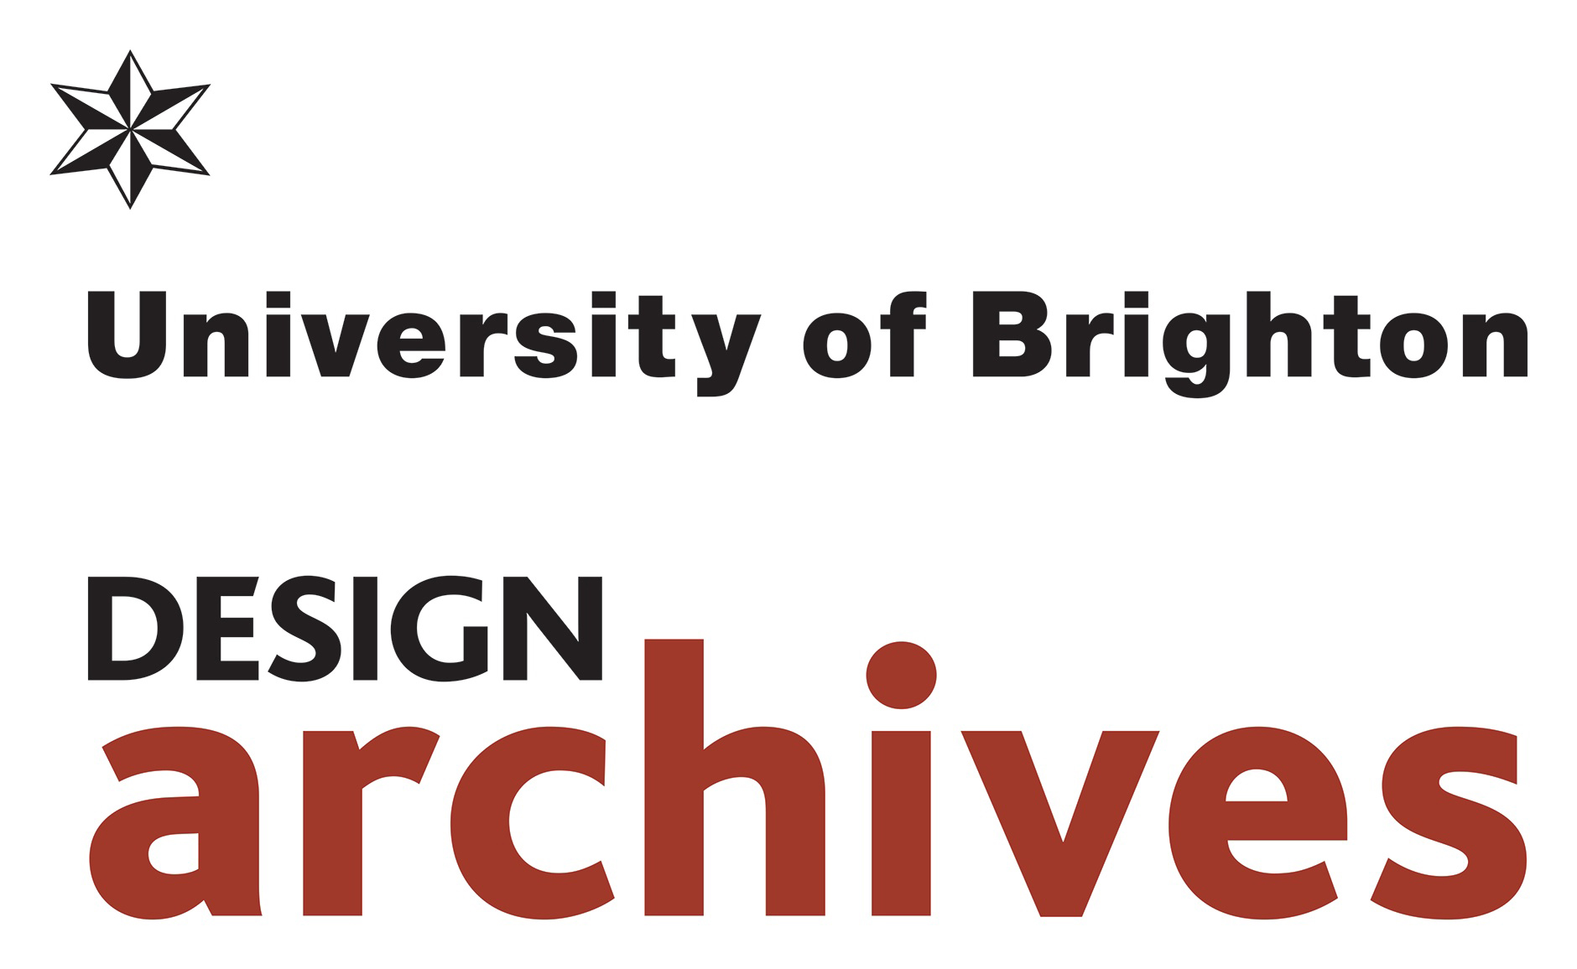 | Access Policy

1. Scope

This document sets out how the University of Brighton Design Archives (UoBDA) provides access to its collections, in support of its mission and strategic goals, in particular the following Design Archives strategic goals (DASG):

DASG 2: Research-informed stewardship
Champion the melding of academic and professional practice through the preservation and interpretation of the collections and an innovative ethos of research-informed stewardship.

DASG 3: Research & Teaching
Embed our collections and expertise at the heart of innovative, creative and inclusive teaching, research, and public engagement activities.

DASG 4: Engagement
Attract researchers and students locally, nationally and from around the world, inspiring scholars and the design, archive and curatorial professions.

DASG 5: Programme
Provoke debate and curate a dynamic programme that links content, enquiry and practice – a cornerstone of the University of Brighton strategy.

2. Related and Supporting Documents

UoBDA Visitor Record and Conditions of Access; Visitor Registration Form: Data Protection Statement
UoBDA Loans and exhibitions policies

3. Our collections and audience

The University of Brighton Design Archives originated as the Design Council Archive in 1996, following the university’s partnership agreement with the Design Council (founded 1944) to look after its historic archive and make the varied materials available for teaching, learning and scholarly purposes. This deposit recognised the leading role taken by the University of Brighton in advancing the subject of Design History as a distinct disciplinary area, since the 1970s. A carefully considered group of further archives, including those of individual designers and globally-significant design promotional bodies ICSID and Icograda, now sit alongside the founding collection, and their contents respond to shared research themes in ways that make this group internationally significant.

UoBDA is accessible to all with an interest in these holdings. We operate an inclusive access policy that embraces members of the public, students and established scholars. While our core audience is academic, we champion the value of our collections to a range of audiences, including artists, curators, heritage professionals, journalists, publishers and programme-makers, and we welcome interest from all parts of the community, in Britain and around the world. We provide access to our collections in a variety of ways, in our own facilities, through other public spaces, and in the online environment.

In 2018 UoBDA won the Sir Misha Black Award for Innovation in Design Education, in recognition of the ‘innovative work in building an impressive complex of resources that embrace teaching, research, the preservation of knowledge and its dissemination nationally and internationally'.

4. Access onsite

The University of Brighton Design Archives opened at the Grand Parade premises of the university in October 1996, and forms part of the University’s City Campus in central Brighton.

Making an appointment

Visitors are asked to make an appointment, by email at designarchives@brighton.ac.uk or by phone at 01273 643217.
These contact details are available on our website. You may wish to outline the focus of your work, and seek further detail concerning our holdings.

We operate an appointment system to make efficient use of reading room and staff availability, but can often accommodate appointments at relatively short notice. We are open throughout the year, except the week between Christmas and New Year, and statutory holidays. The Reading Room is open 9.30 - 12.30 and 1.30 - 4.45 from Tuesday to Thursday, and to 4.30 on Friday.

We recommend that, where possible, visitors tell us in advance what they would like to see, using information available through the Browse Our Archives area of our website (http://arts.brighton.ac.uk/collections/design-archives/archives), or in consultation with Archives staff.

Arrival and registration

Brighton is easily reached by train from London and from Gatwick Airport for international visitors. A map and other location details are available on the Contact page of our website (http://arts.brighton.ac.uk/collections/design-archives/contact).

External visitors should report to the reception desk in the main foyer of the Grand Parade building. First-time visitors will be collected by UoBDA staff. Alternative arrangements can be made for visitors with mobility impairments.

The UoBDA is a secure space, and the reading room is invigilated. You will be asked to use the lockers for your bags and personal belongings, and to leave coats in the reception area.

There are two fire exit routes (to the front and rear of the building). All UoBDA staff are trained fire wardens and familiar with the university’s evacuation procedures. In the event of a fire, visitors must follow staff instructions.

Visitors have access to other publicly accessible facilities in the building, including wifi, galleries, café, restaurant, and events spaces.

Our Conditions of Access are available on the Contact page of our website (http://arts.brighton.ac.uk/collections/design-archives/contact). These conditions include the following information:
* your obligations in terms of handling archive material
* what you may bring with you into the reading room.
* how to take or order copies of material during your visit

On arrival, you will be asked to to complete the Visitor Registration Form, providing contact details and outlining areas of interest, and your signature to confirm your agreement with our Conditions of Access. The information contained in these forms is used to generate statistics and guide policy formation. They are stored securely in accordance with the Data Protection Act 2018 (see UoBDA Visitor Registration Form: Data Protection Statement).

Material stored offsite

A small amount of material is stored offsite at The Keep. https://www.thekeep.info/about_us/
Design Archives staff will advise if this material may be relevant for your research. Separate access procedures apply for this material.

5. Remote Access

Information about our collections, and selected digitized content, is available from a variety of online locations:

Design Archives web pages

A description of each of our archive collections is available on our website, and a link to the listing of that collection: http://arts.brighton.ac.uk/collections/design-archives/archives

Not all our collections are catalogued, but all have a box list, and further information can be provided by staff knowledge to support your research.

Our website provides access to a growing selection of archive material, including a suite of ‘turning pages’ resources, Flickr sets and other curated content.

The Design Archives has an entry on the National Archives Discovery resource: https://discovery.nationalarchives.gov.uk/details/a/A13532684

Catalogue descriptions

UoBDA catalogue records are uploaded incrementally to the following online locations:
Design Archives catalogues only: https://archiveshub.jisc.ac.uk/designarchives
Archives Hub https://archiveshub.jisc.ac.uk
Archives Portal Europe. http://www.archivesportaleurope.net
Selected items are digitized with digital objects attached to the catalogue records on these websites: for example 2,000 poster images from the Icograda archive. Where indicated on the catalogue record, some documents may also be ordered as PDFs.

Other web locations

Since 2002 more than 3,000 of our images have been available via the Visual Arts Data Service (www.vads.ac.uk), as well as a suite of dedicated e-learning modules (https://vads.ac.uk/resources/index.html).

Research & Enquiry Service

You may email or call us with initial enquiries about our holdings: designarchives@brighton.ac.uk or 01273 643217.

For researchers who are unable to visit, we offer an hourly paid research service, subject to the availability of staff time. Further details are available here https://shop.brighton.ac.uk/product-catalogue/books-publications-merchandise/design-archives/design-archives-research-fee.

Requesting copies
You may request copies of Design Archives collection items, subject to the item’s condition and to copyright restrictions, which will vary from item to item: Archive staff will be able to advise on restrictions that may apply for a particular item.
For private research, watermarked PDFs or photocopies may be supplied. For publication, high quality scans are provided. Charges will apply for production and/or for reproduction: please ask archive staff for further details.

6. Other ways to engage with our Collections

UoBDA staff undertake a range of engagement strategies to widen awarenss of the scope and potential of our holdings.

UoBDA has an established track record in generating research projects and resources, which generate their own online content and coverage. Research by staff and visiting scholars has been widely published; and UoBDA material has appeared in museum displays, exhibitions, television programmes, and journalism, often curated in collaboration with other cultural institutions. The News page of our website is regularly updated to reflect our current activities, and such activities are also promoted through social media. See http://arts.brighton.ac.uk/collections/design-archives/news
https://twitter.com/Design_Archives

Publications
As well as sharing news of our own publications, we encourage reseachers to keep us informed of the progress of their research to publication, so that we may promote it through our channels.

Loans and Exhibitions
We work collaboratively to bring our collections to wide public audiences through exhibitions, both at the University of Brighton and through loans to other institutions. Institutions wishing to borrow materials should address their request to the Archive Leader via designarchives@brighton.ac.uk

Events
UoBDA staff deliver introductory workshops to UoB arts and humanities students at both undergraduate and postgraduate levels. They also contribute to other units of teaching and supervise doctoral students. Staff will also deliver introductory sessions to visiting groups from other educational institutions, by arrangement. We represent our work and the collections locally and internationally at public events, professional meetings, conferences, and networks. Please email designarchives@brighton.ac.uk.

7. Restrictions on access

Legislation
Most of our holdings are freely accessible. However some material is subject to legislative restrictions on its access, primarily in accordance with the Data Protection Act (2018) and the Freedom of Information Act (2004). Decisions on access are taken by the Archive Leader and/or the Deputy Curator. Our Conditions of Access and its accompanying Data Protection statement cover your obligations under the Data Protection Act.

Uncatalogued collections
In the case of uncatalogued collections, access is generally provided wherever possible. Some material may be caught by the afore-mentioned legislation, in which case the Archivist / Archive Leader or the Deputy Curator will determine whether the material can be made available to researchers.

Preservation and surrogates
Some materials may be judged by Design Archives staff as unfit for access by researchers, due to poor physical condition. Such items will be highlighted to our conservator and added to a list of items needing conservation treatment. Where possible, we will offer alternative means to access the information. This may include surrogates where they will be beneficial for teaching or research needs.

Born-digital records
There is currently no access to born-digital records. The aim in future is for access copies to be made available, via a stand-alone computer in the Reading Room. Feasibility of this approach will be part of the Interim Digital Preservation POlicy, Plan and Procedures.

University of Brighton records
Although we hold small amounts of material relating to the history of the Brighton School of Art, we do not hold institutional records relating to the University, including student records. For such enquiries, please contact alumni@brighton.ac.uk

8. Feedback

We aim to provide a welcoming, courteous and supportive learning environment. We welcome feedback from visitors to our Reading Room and web resources alike. If you have a suggestion or comment please email us
at designarchives@brighton.ac.uk.

Document Control
Author: | Dr Lesley Whitworth, Deputy Curator
Owner: | University of Brighton Design Archives
Approved by: | Professor Andrew Church, Associate Pro-Vice Chancellor (Research & Enterprise); Professor Stephen Maddison (Head of School of Humanities)
Date Approved: | November 2019
Document Number:

Version History
Version | Version date | Summary of Changes
V1 | 2018
V2 | November 2019 | Updated and revised by Sue Breakell, Archivist / Archive Leader

