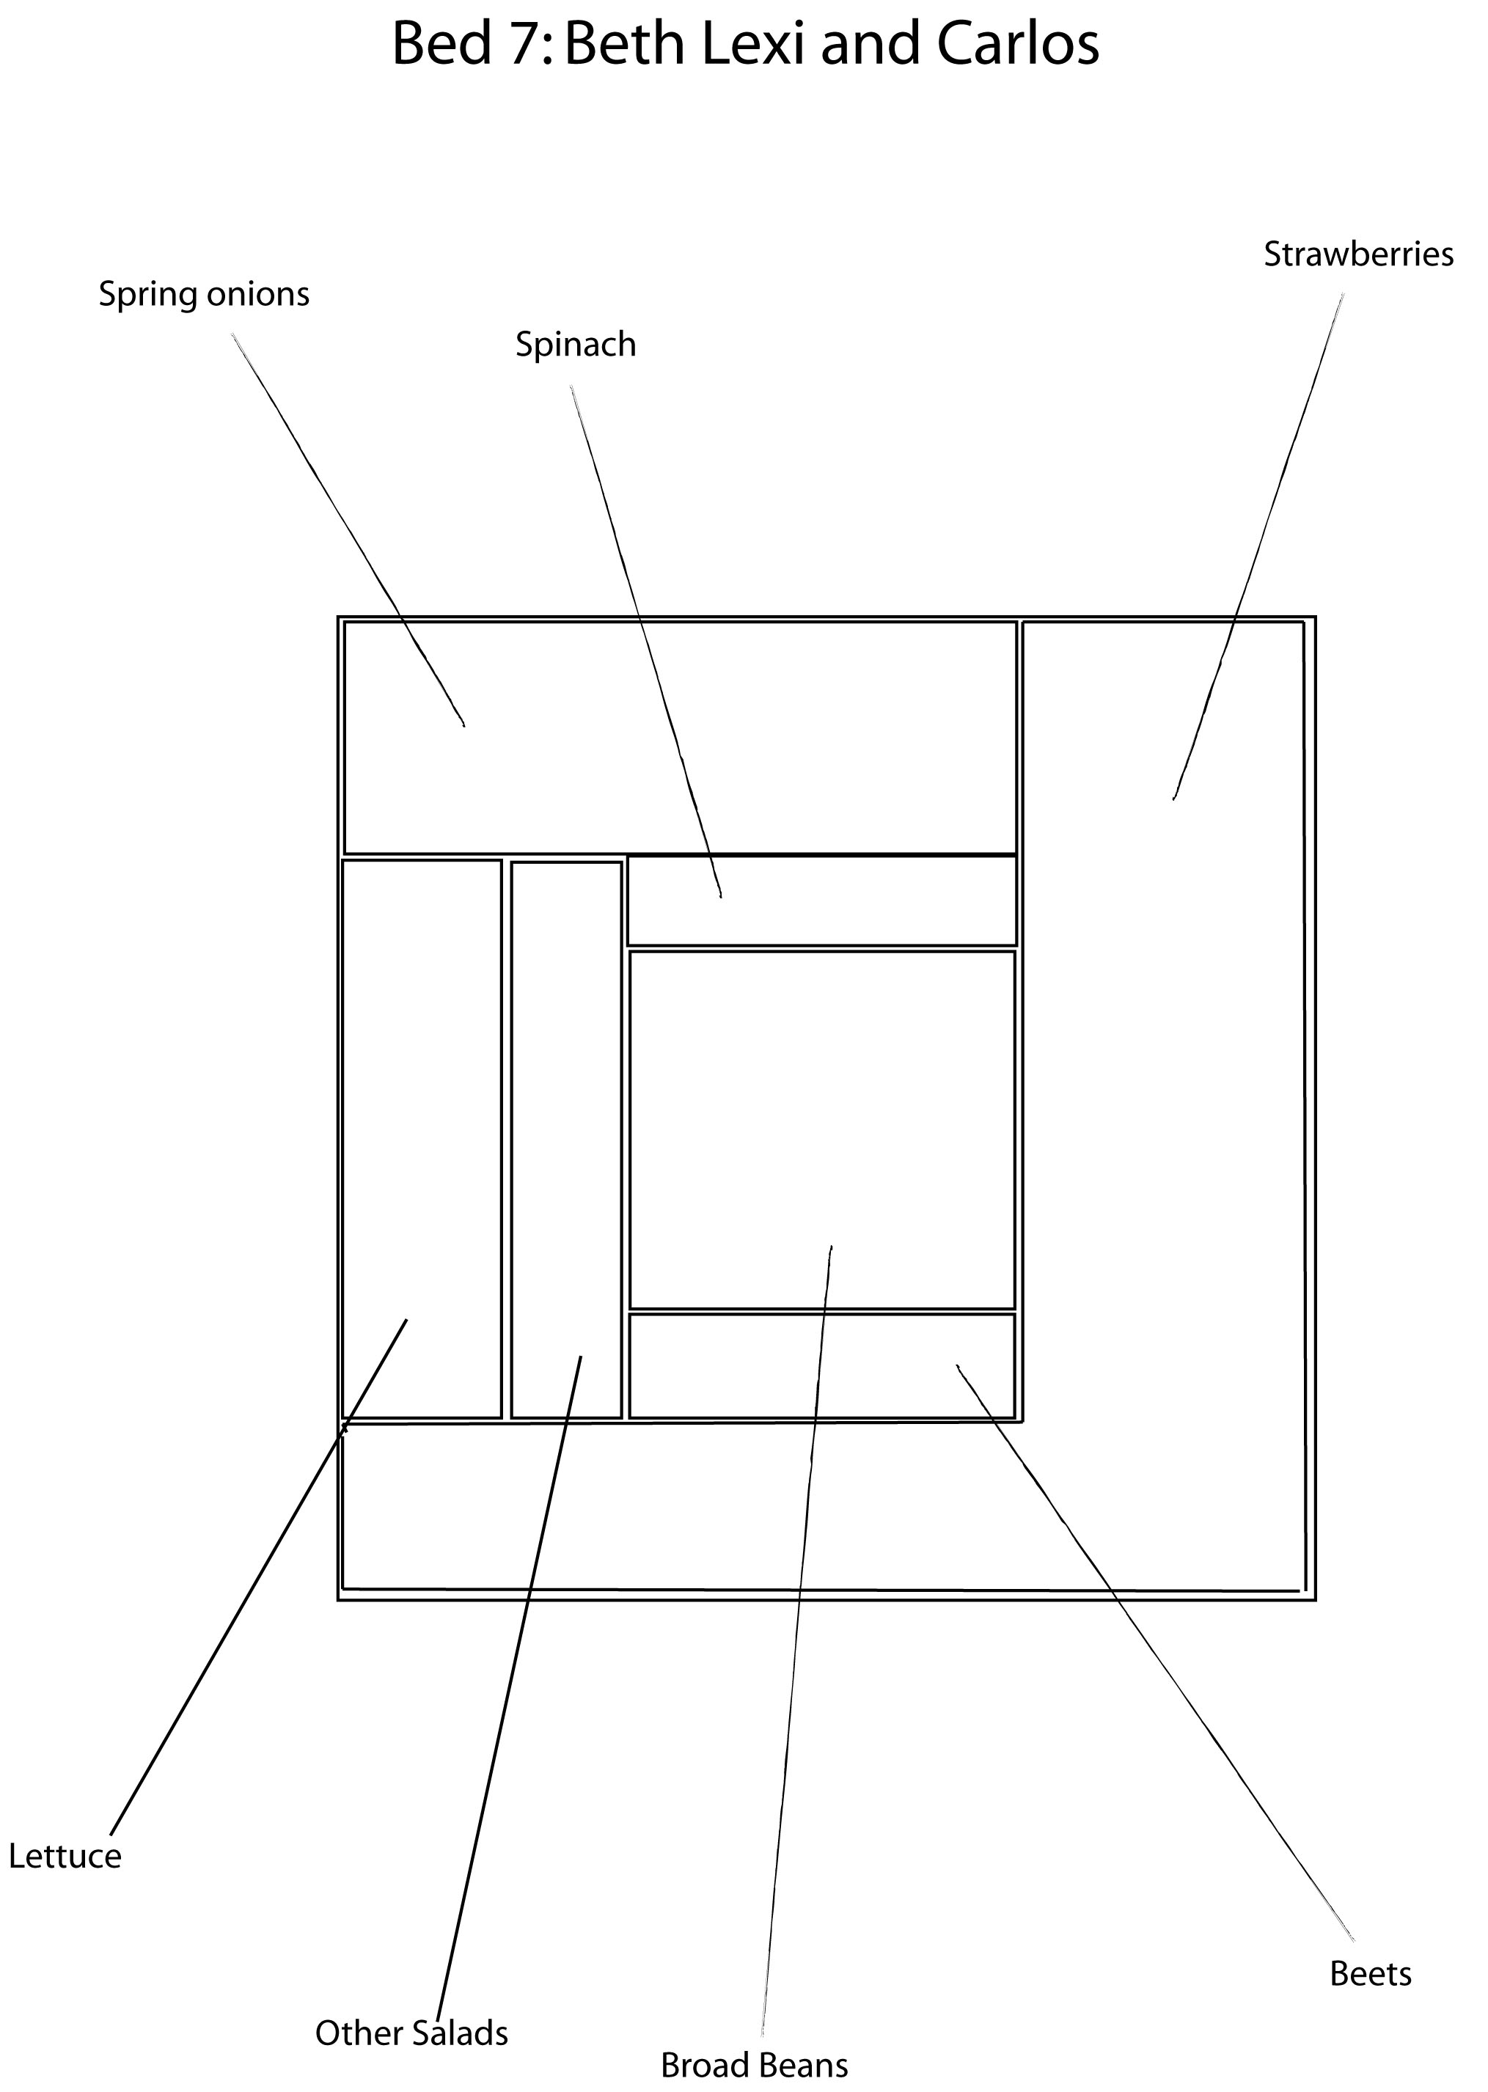

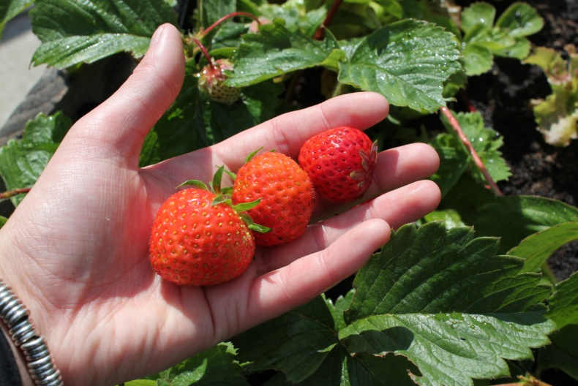
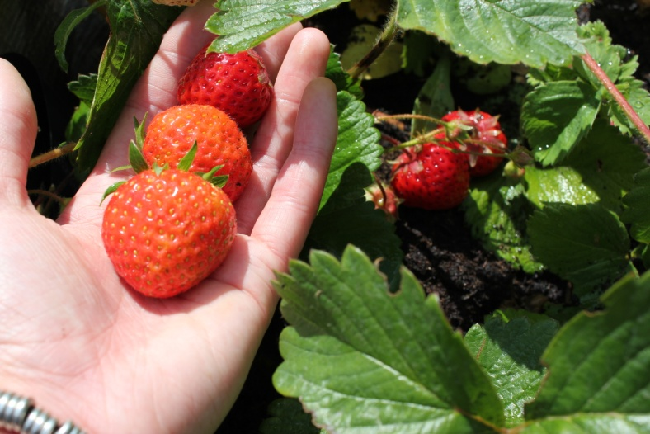

First harvest of strawberries
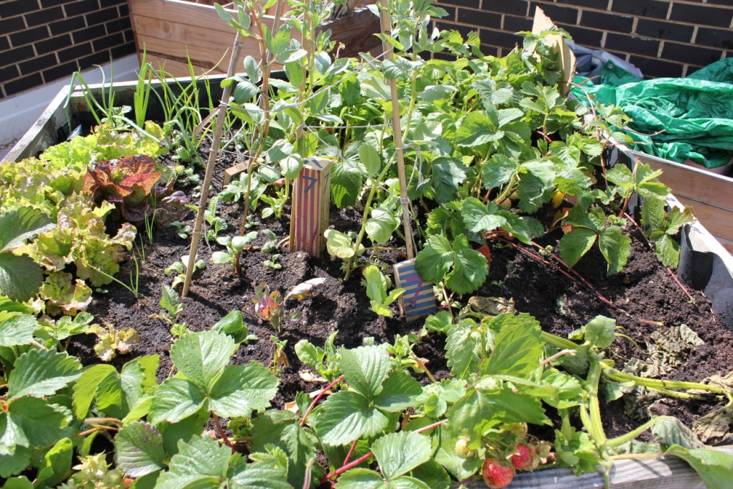

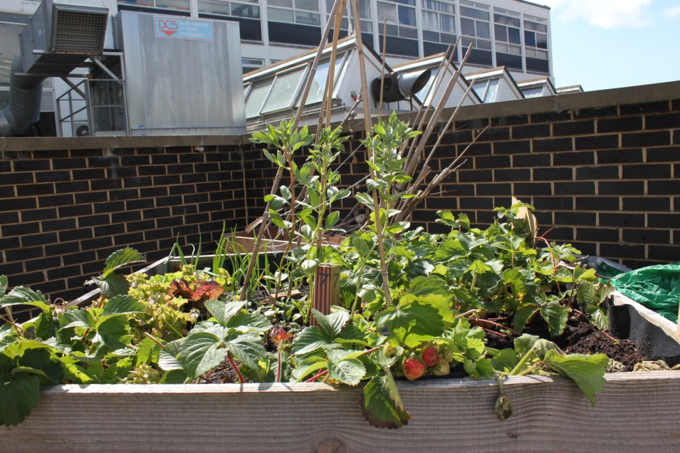

Bed 7 in late May
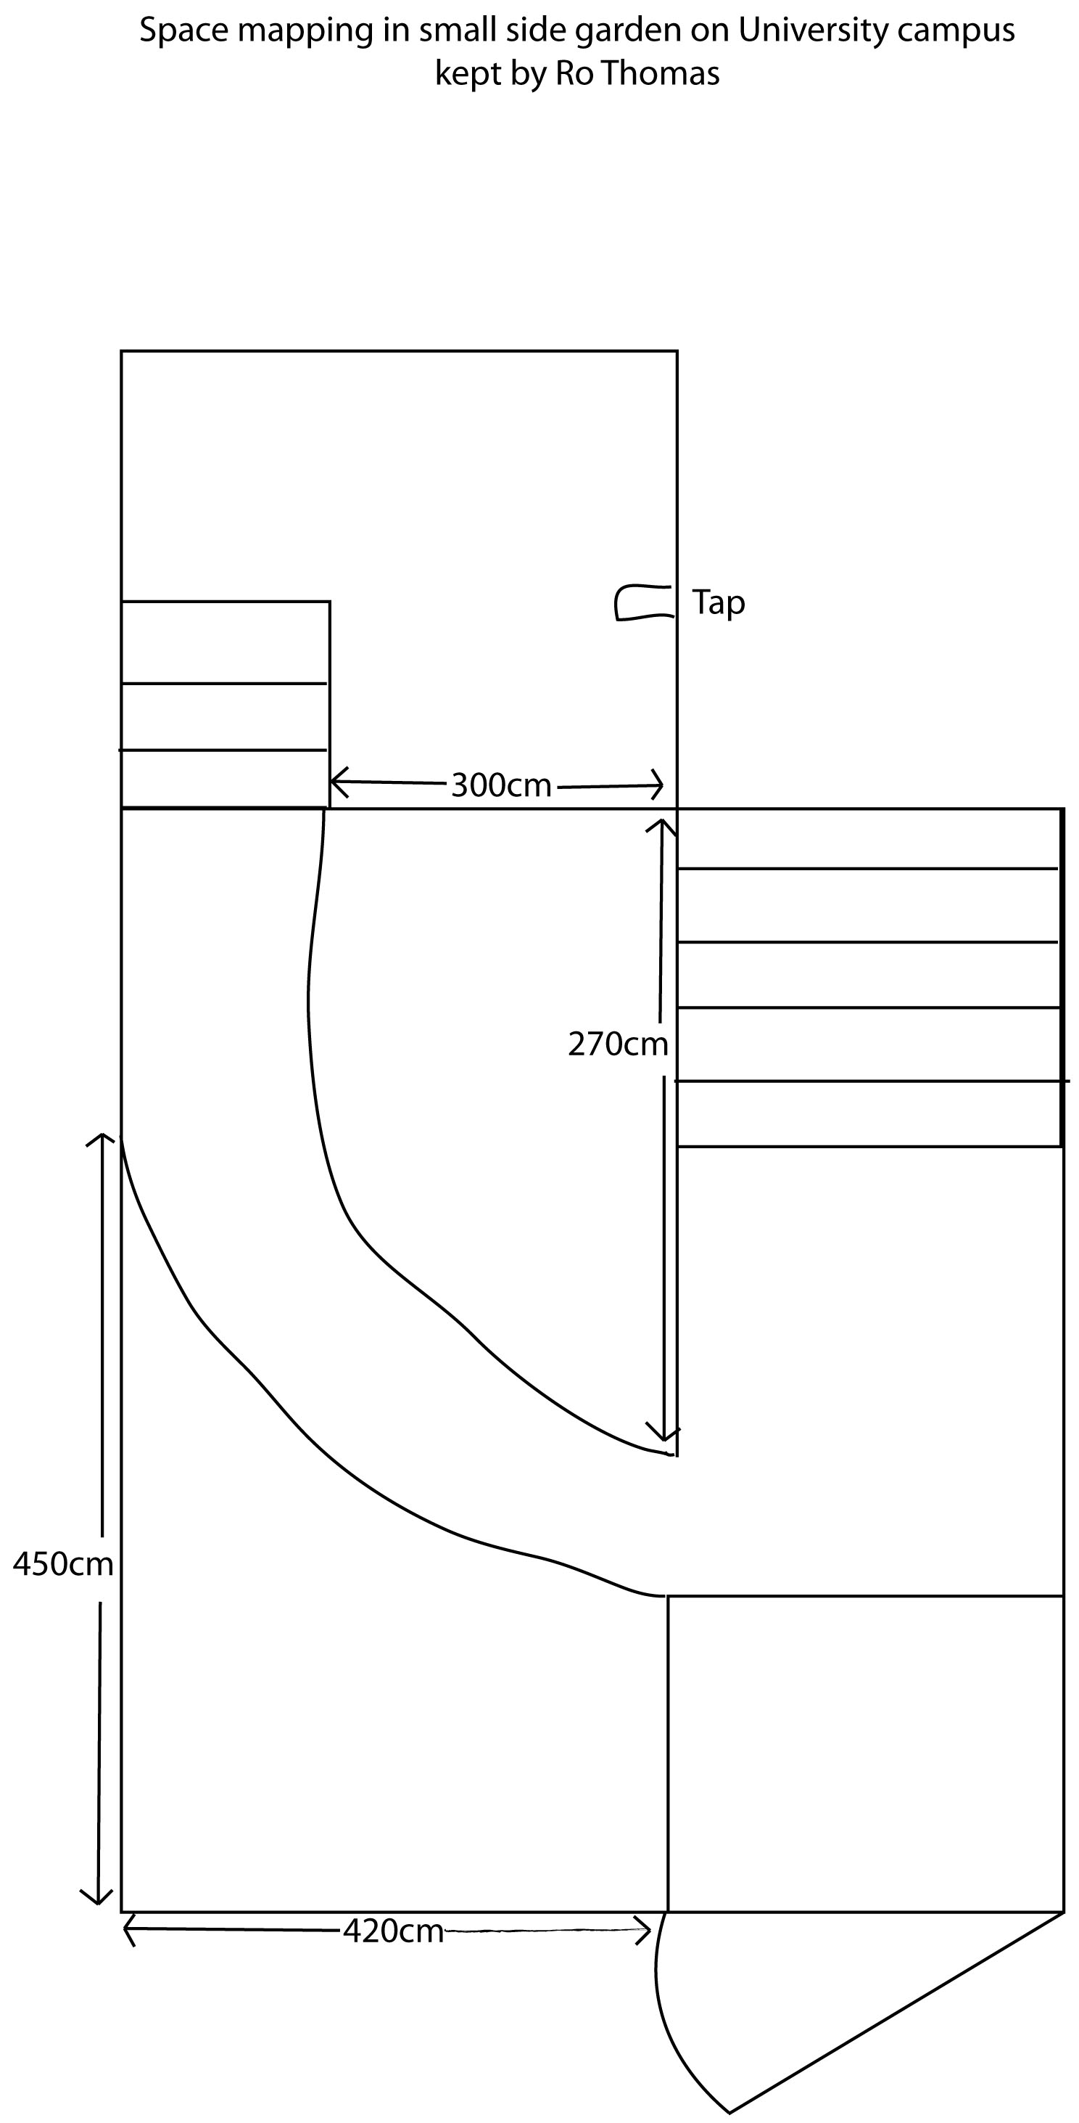

There is a small secluded garden at the rear of the university running alongside the offices in G55. Extension studies administrator Ro Thomas tends it for her own enjoyment as she has no garden of her own at home, this patch provides a perfect opportunity to experiment with growing and create a space where wildlife can flourish. I visited the space with Ro to see if there was any room for transferring the excess flowers living in our growing beds and see how she had been getting on there.

What do you feel is going well in your garden?

I feel the majority of things are going well in the garden, especially the delphiniums which I've had to nurture through the winter and didn't think would re-surface this spring!

What have you found challenging?

Watering used to be very challenging before an outside tap was installed. The soil is full of flint, stone, bits of brick, scaffolding parts, building materials etc. even children's toys which can make for quite hard work at times, although always enjoyable. Plus the never-ending population of slugs and snails!

What is your vision for the garden?

I don't have a particular vision - I'm well aware that the garden belongs to the university rather than myself so I try to curb my enthusiasm, plus I'm trying to do everything as cheaply as possible so I buy reduced price and clearance plants which aren't necessarily what I'd choose to grow.

Have you ever thought of growing food in it?

No. I tried tomato plants last year but like the edible campus watering can be a problem. Herbs I'm OK with and I have Jerusalem artichokes growing but only for the flowers rather than the produce! I enjoy the flowers and each year I'm constantly surprised by what suddenly appears or reappears through the earth.

Where have you picked up your growing skills and knowledge?

I'm a very hit and miss, cavalier type of gardener. I've no idea about soil conditions, position etc. I plant what I like and it either survives or doesn't! Both my parents, sister and brothers are all excellent gardeners so I expect some of their knowledge has rubbed off on me but I like to plough my own furrow - if you'll pardon the pun!

When I visited the garden again I noticed several types of colourful bird living in and around the garden, showing how important it is to create places like this in urban environments to encourage the survival of wildlife.

‘’We have some lovely little birds in the garden including greenfinches, chaffinches, the occasional bullfinch, goldfinch and robin, blackbirds, thrushes, lots of blue tits and a couple of great tits, dunnocks and sparrows. 5 starlings have fledged in the last two weeks as have 2 collared doves. It costs a fortune in bird feed but well worth it!!’’

Chaffinch Greenfinch

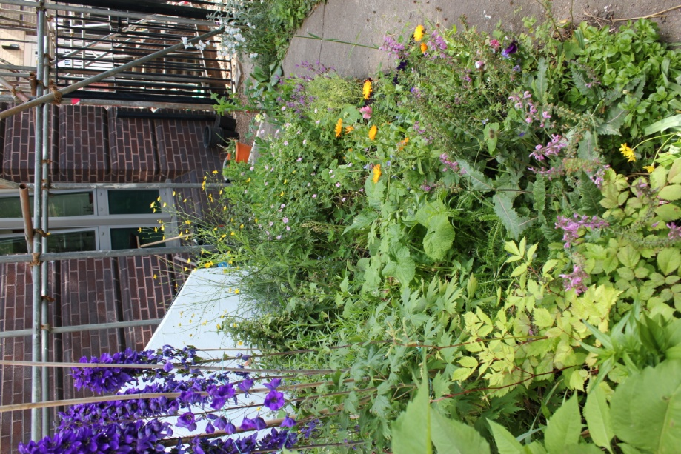
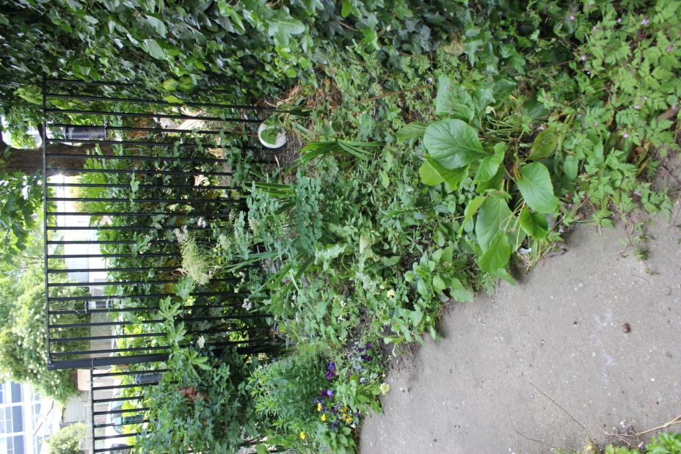

University side-garden in late May

