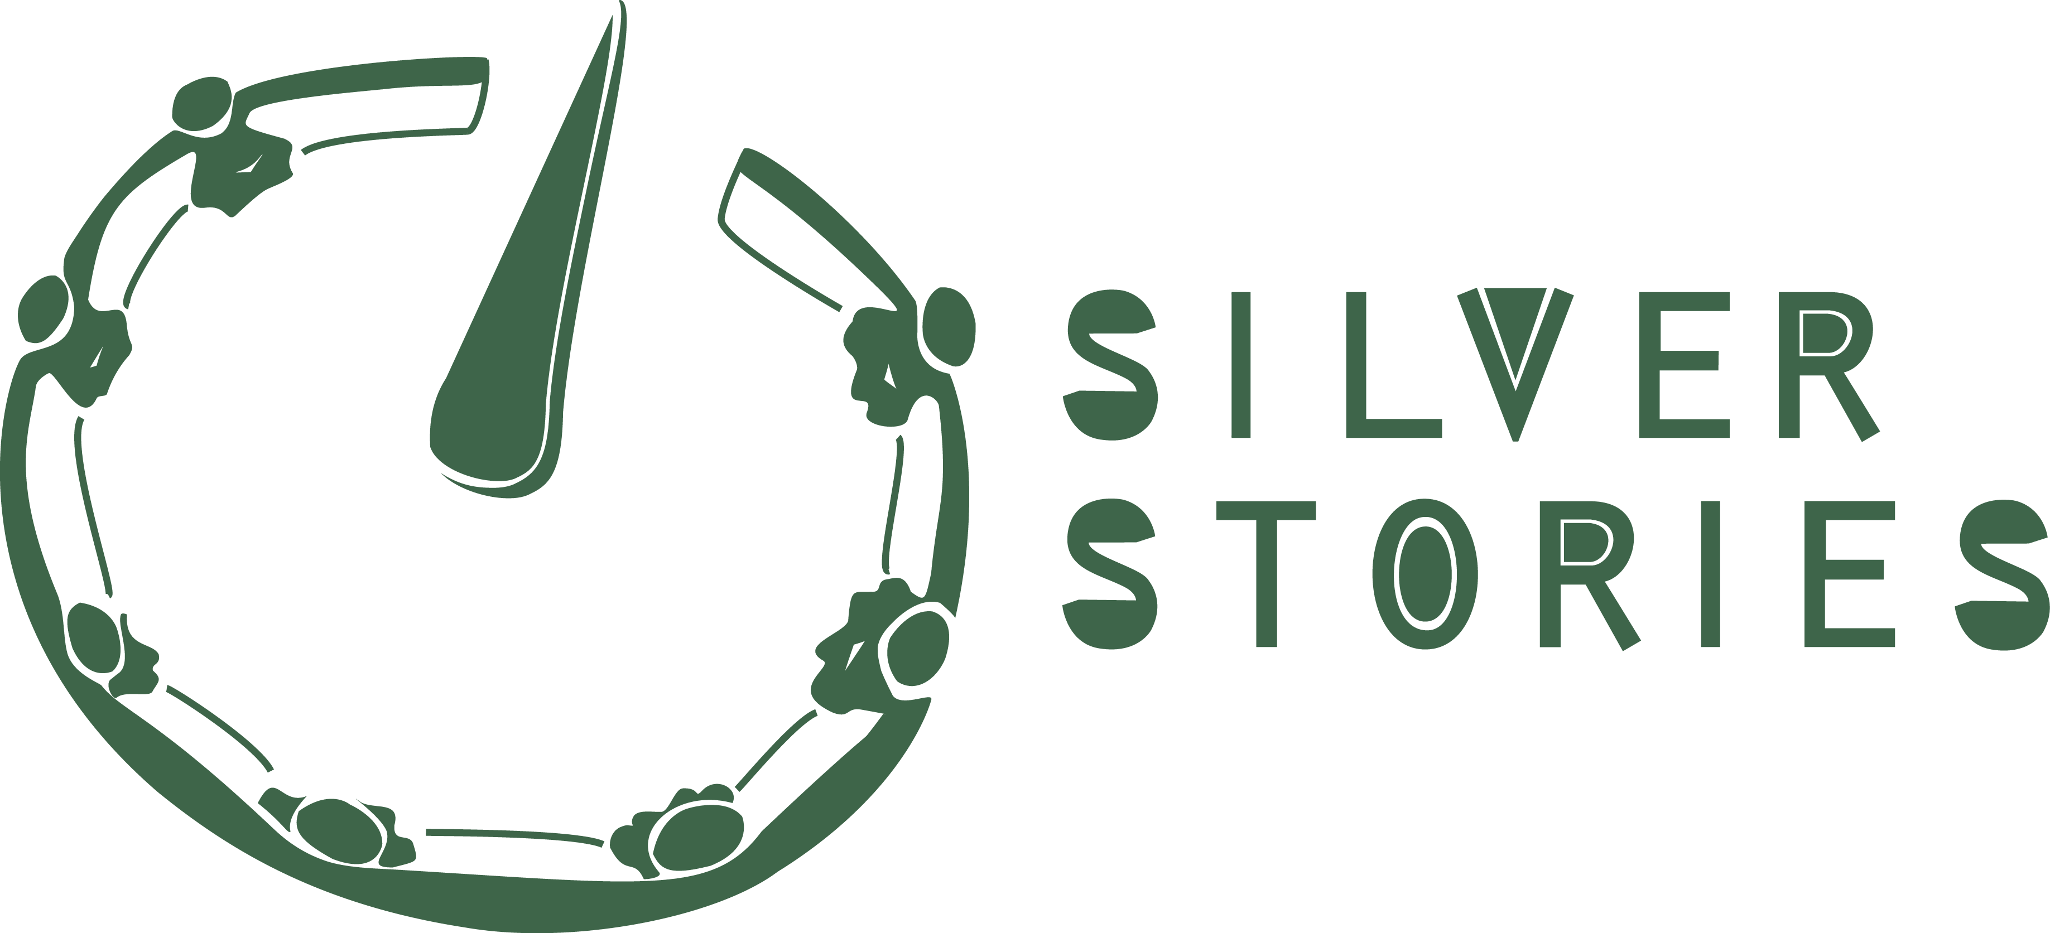

Module Delivery Plan Transfer One

Prospective Trainers of Third Age or ´active older´ people

Title | Digital Storytelling for professionals wishing to work with stage three older people
Context | Digital Storytelling workshop for Trainers wishing to work with Third age active older people, taking place in educational establishments (colleges or universities), libraries, arts centres, residential homes or community venues.
Purpose | The purpose is to provide trainers with the skills, knowledge and experience needed to train active older people in digital storytelling to enable them to use ICT including the internet.
Aims | The aim is to provide trainers working with active older people with the ability to prepare, run and evaluate a digital storytelling workshop. The workshop will give trainers working with active older people the means to facilitate the training of active older people to produce digital stories.
Description | The programme is divided into five elements:  i) an introductory section covering digital storytelling and creative work with active older adults;  ii) story circle workshop – experiencing story circle and exploring ways in which the classic model can be adapted to meet the needs and capacity of each storyteller ,  iii) production of digital stories – how to record voice, scan and manipulate images and edit a story  iv) Screening  v) Reflective evaluation.  It mixes classroom-based activity, creative and technical workshop and requires significant independent study in each element.
Learning Outcomes | By the end of the module, participants should be able to:  - Understand the production processes of digital storytelling  - Create digital stories in video editing software, incorporating still and/or moving image  - Understand how to adapt the “classic” model of digital storytelling to enable older people to participate  - Clearly articulate knowledge of the forms and practices of digital storytelling  - Analyse digital storytelling as an autobiographical act  - Reflect critically on the ethical concerns relating to the use of autobiographical material
Resources | Facilitator(s) – one facilitator per 8 students. ICT laboratory, or one laptop per student, scanner, internet access, digital camera/video camera, audio recording device. Flexible space for Story Circle activities. Quiet area for sound recording. Art materials and stationery.
Schedule | 40 taught hours plus 160 hours guided independent study
Structure | Each taught session has a structure with times, breaks and deadlines. Taught workshops should total approximately 30 hours, and could comprise, for exam, 16 hours preparation time in advance of element two, 32 hours contact time during element two and three and120 hours in element four.
Workshop Outcomes | Increased knowledge and skills in the use of ICT; facilitation skills to enable participants to support 3rd age older people to create a digital story; ability to tell a short personal story as a digital story; understanding of reflective practice.
Workshop outputs | Each participant will make a digital story and complete a reflective essay.
Evaluation | The module will be evaluated in accordance with institutional practice.
Progression | The module can be taken as part of a healthcare or social work qualification or as stand-alone Continuous Professional Development (CPD) for those already employed in working with older people.

Delivery Plan detailed:

Context:
This Digital Storytelling module is for professionals and/or volunteers who may go on to work with older people in educational institutions, museums, arts or community centres or residential homes, or a place where the older people can feel safe and in an environment that supports and appeals for a creative and safe process.
Aims:
This module will provide prospective trainers with the skills, knowledge and experience needed to train older people in Digital Storytelling. The aim is to enable trainers to engage older people in a new and interesting way to open a window into the world of digital technology. The output of a digital storytelling workshop is a two to three minute digital story using word and imagery to tell a personal story. Older people who have not grown up with digital technology and who find it bewildering will find a new, creative route into digital media.

The trainee will acquire skills and knowledge needed to use digital storytelling as a means to enable older people to:
- Be digitally empowered
- Find personal strengths
- Develop narrative skills
- Develop written skills
- Learn about visual storytelling
- Develop technical skills
- Socially interact
- Learn new skills and transmit them onwards via the internet
- Preserve and tell life stories and history
- Develop skills for the future learning
- share stories and experiences
- share knowledge through social online groups or follow up
Description:
Course content is divided into four elements:

Introduction (16 Hours). Two introductory sessions of four hours each will provide an overview of digital storytelling and the issues it raises. The first session will look at different digital stories to give prospective trainers with the quality, range and number of stories made across the globe. The second will explore the background to digital storytelling and focus on some key issues which shape and inform practice (e.g. copyright, ethics, clearances, etc. It will provide an introduction to working with older people, providing context, ethical issues, examples of good practice and introduction to the digital storytelling process – the ‘classic’ seven steps model and how this can be adapted to meet the needs of older people. Examples of digital stories should provide prospective trainers with a range including but not exclusively from the target group, to a sense of the quality, range and number of stories made across the globe. Discussion of key issues which shape and inform practice with vulnerable people, including ethical questions around consent, are essential within this phase.

Story generation/ ‘story circle’ (8 hours workshop). Experiencing story circle, the ‘seven steps’ and making own digital story. It is important for students to make their own personal digital story in order to experience the process first hand, so that they can understand the physical, cognitive and emotional demands of the process. During the process, students will explore ways in which to adapt the classic story circle model to meet the needs and capacity of each individual storyteller. It will demonstrate techniques such as utilising photographs, objects, stories or story fragments to develop a digital story with the participant and, if appropriate, their carer. It will focus on shifting from the collective approach to story circle, to one-to-one methods of working. Developing a script, writing a script. Reflection on ways to approach script development with older people who may not have the capacity to write a script.

The importance of careful planning and design of DS workshop with older people, placing the needs of each individual at the centre is paramount and students will be required to reflect upon this as they travel through the process themselves. It is important to ensure that the older person feels that they are valued, productive and respected and that their story is important.

Production of digital stories (20 hours workshop). How to record voice, scan and manipulate images, edit a story. How to enable a storyteller to construct a story and to be able to learn how to do this themselves.

Sharing Stories (4 hours workshop) students will have made their own stories, which will be screened and shared with the group.

Reflective evaluation of the Digital Storytelling process Students will be required to reflect on the adaptation of the process to meet the needs of older people and the impact of the process and the sharing of the final product on individuals and their families. They will use a reflective model to consider their experience during the workshop and to review how this could be adapted or used to facilitate a digital storytelling workshop with older people. This seminar session will take place approximately one week after the workshop and participants will be encouraged to share their reflections before hand through a shared web resource so they can be discussed in a seminar. Participants will then be asked to write a reflective essay of approximately 2,500 words exploring the use of Digital Storytelling with older people

Teaching and Learning Activities
Element One: Introduction

Lectures, workshops and seminars providing the history of the Digital Storytelling movement
Screenings and analysis of digital stories; working with older people – approaches and considerations. Copyright considerations and use of creative commons image and sound.

Element Two: Story Generation

Students will be generating their own stories through the Story Circle activities as a group, however they should consider at all times how they would adapt these techniques to working with older people. At the end of Element Two, students should have selected their images and written their scripts.

The following Story Circle techniques can be adapted to working with older people:

a) Conversation stimuli:

My life reflections´ ´(Can you tell me about the time you..(got married, had your first job, your children were small, etc. What did you used to do for work?” What work/job did you enjoy best?” “Do you enjoy sports?
´My Family and Home´ (“Can you tell me who this is?” (use family album). Tell me about your home, what do like best about it?”
Are you an animal lover? Do you have pets?”
´I look forward to...(hopes and dreams)

b) Creative exercises to stimulate memory:
Using photographs of themselves past and present;
Using music or a voice recorder with favourite songs, poems etc.
Using objects or images (photographs or paintings) to elicit responses to them;.
Word association exercises.

c) Generating stories through conversation:
- Use open questions and record responses. Transcribe them and present back to the person.
- Match elements of the person’s story to images; possibly generate additional images if required.

Element Three: Production of own Digital Story

Use the story circle to share script and obtain feedback from group
Make any amendments and record voice-over
Instruction in editing software (iMovie, Movie Maker or WeVideo)
Editing the story, matching images to voice over and adding additional sound, transitions, titles.
Export the movie for the web, save to memory stick and burn to DVD.
Publish the movies.

Element Four – Reflection

Celebratory Screening

Sharing of stories with peers and wider group (family, friends, community) is an important element of the digital storytelling process.

Element Five Reflection

Consideration and discussion of the impact of the process of Digital Storytelling on themselves. How can the process be adapted to different situations when working with older people? What problems might be encountered and how would these be overcome? What ethical issues need to be considered?

Resources:
Space: It is useful to arrange three rooms for the workshop. Element one and Element Three are classroom based.

1. Production room: This is where the digital stories will be made. The room needs to have enough space, tables and chairs to accommodate all the equipment and people. It's important to make the room comfortable for the participants as well as natural light and ventilation.
It should be possible to make the room dark enough for images from the data projector to have impact. There should be a bathroom and eating room close by.

The room can be divided into small island of tables and chairs where the participants can sit in smaller groups. At the final screening move furnitures in rows – facing the screen. Allow space for the projector to show from the back of the room.

The space of the room should be big enough to accommodate additional equipment (scanners, printer, camera chargers, etc.)
There should be room enough to allow trainers to move comfortably between storytellers. The room is also the venue for the storycircle where chairs should be placed in a circle.

2. Audio room
The sound recording room need to be a silent room with clear acoustics, where the door can be closed and locked. Make sure that any noise from air-con, printer, fans or computers are switched off. Windows should be closed and the room should be available throughout the whole workshop.
Make a voice-recording station with a computer, a microphone, power points and comfortable chairs. If the room tends to have echo, a way to prevent this, is to put a pillow or blanket around the microphone.

3. Relaxing space
This third room is important, because the participants need to have a space to relax and get a break from the workshop.

Technology:
Computer with an editing software, e.g. Windows Movie Maker, Imovie
Microphone / digital dictaphone
Headphones and splitsticks
Digital stills camera
Scanner or printer
Projector
Speakers
Materials:

Photos/postcards to choose from
Pieces of paper to write or draw on
Colour pens
Timetable and a watch for the storycircle

The participants need to bring:
20-30 photos from the family album or digital photos
A favourite object
(USB)
Schedule: (*This structure is to be reviewed according to the participants and place)
The module is delivered in teaching sessions of four hours duration spread across the different elements. This totals 44 hours of direct contact time.
Students’ self managed, independent study including reading, note taking, collation of materials, writing, preparation for seminars and completion of assessment tasks will greatly outweigh the amount of contact time.
Assessment (*

There is one assessment task for this module which is a portfolio comprising of three parts:

A short digital story (3 mins) incorporating still and moving image
written contributions to a reflective seminar and participation in the seminar

A 2,500 word reflective and conceptual essay contextualising the digital storytelling workshop process and exploring the use of the practice for subsequent workshops

Progression:
Digital storytelling is simply a means for caregivers, social workers, volunteers, families etc. to enable older people to use ICT and to learn from the older peoples stories. On completion of the module, trainers will have the skills, knowledge and experience needed to organise and deliver digital storytelling workshops with older people.

The sharing of the stories and activities after the workshop is important both for the participants and other people. The storyteller will often take pride in his or her story, and one of the key issues for engaging other older persons is to make the workshop participants ambassadors for digital storytelling in order to promote it for other older people to do the same.

There can be public screenings, exhibitions or festivals where the old people will share their stories. It could also be that the stories are used for communication, political statement or in the health care system.
Literature/materials:
Books

Hartley, John and McWilliam, Kelly (2009) Story Circle Digital Storytelling Around the World (Wiley Blackwell)
Lambert, Joe, (2013): 4th Edition – Digital Storytelling, Capturing Lives, Creating Community, Routledge.
Lundby, Knut (2008): Digital Storytelling, Mediatized Lived (Peter Lang)
Plummer, Ken (2001) documents of life 2: an invitation to critical humanism (Sage)
Thumim, Nancy (2015) self representation and popular culture (Palgrave Macmillan)

Websites

http://www.storycenter.org
http://www.bbc.co.uk/wales/audiovideo/sites/galleries/pages/capturewales.shtml
http://www.acmi.net.au/collections-research/community-engagement-projects/digital-storytelling/

